PROJECT TITLE

V/F speed CONTROL OF 3 PHASE INDUCTION MOTOR DRIVE

TABLE OF CONTENTS :

1. INDUCTION MOTOR ( Pg 5-29)

* STRUCTURE
* **OPERATING PRINCIPLE**
* PRODUCTION OF ROTATING MAGNETIC FIELD
* **TORQUE EQUATION**
* **TORQUE - SLIP CHARACTERISTICS**
* **SLIP -SPEED CONTROL**
* **SPEED CONTROL METHODS**

1. POWER ELECTRONICS (Pg 30-69)

* POWER DIODE
* IGBT
* HALF BRIDGE VOLTAGE SOURCE INVERTER
* 3 PHASE VSI 180 CONDUCTION MODE
* 3 PHASE VSI 120 CONDUCTION MODE
* **3 PHASE PULSE WIDTH MODULATION TECHNIQUE**

1. CONTROL SYSTEM (Pg 70- 85)

* **OPEN LOOP AND CLOSED LOOP**
* STEADY STATE ERROR
* **CONTROLLER – P , PD ,PI , PID**

1. ELECTRIC DRIVES ( Pg 86-128)

* POLE CHANGING METHOD
* POLE AMPLITUDE MODULATION
* STATOR VOLTAGE CONTROL
* **V/F CONTROL**
* ROTOR RESISTANCE CONTROL METHOD
* SLIP- POWER RECOVERY SCHEME
* **CLOSED LOOP CONTROL OF VSI FED INDUCTION MOTOR DRIVE**
* CLOSED LOOP CONTROL OF CSI FED INDUCTION MOTOR DRIVE

1. MATLAB SIMULATION( Pg 129-144)

* SIMULATION OF SINGLE PHASE INVERTER
* SIMULATION OF 180 DEGREE CONDUCTION MODE OF THREE PHASE INVERTER
* SIMULATION OF 120 DEGREE CONDUCTION MODE OF THREE PHASE INVERTER
* **SIMULATION OF THREE PHASE SINE PULSE WIDTH MODULATION( PWM) INVERTER**

OBJECTIVE:

V/F SPEED CONTROL OF 3 PHASE INDUCTION MOTOR DRIVE USING MATLAB SIMULATION

1.

INDUCTION MOTOR

Top of Form

Bottom of Form

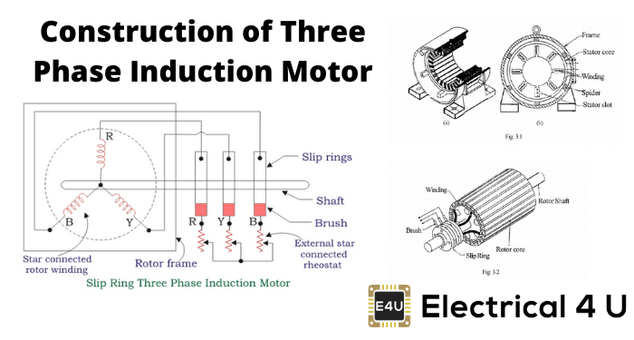

The [three phase induction motor](https://www.electrical4u.com/working-principle-of-three-phase-induction-motor/) is the most widely used [electrical motor](https://www.electrical4u.com/electrical-motor-types-classification-and-history-of-motor/). Almost 80% of the mechanical power used by industries is provided by three phase induction motors because of its simple and rugged construction, low cost, good operating characteristics, the absence of commutator and good speed regulation. In three phase induction motor, the power is transferred from stator to rotor winding through induction. The [induction motor](https://www.electrical4u.com/induction-motor-types-of-induction-motor/) is also called a [synchronous motor](https://www.electrical4u.com/induction-motor-types-of-induction-motor/) as it runs at a speed other than the synchronous speed.

**3 Phase Induction Motor Construction:**

Like any other type of electrical motor induction motor, a 3-phase induction motor is constructed from two main parts, namely the rotor and stator:

1. Stator: As its name indicates stator is a stationary part of induction motor. A stator winding is placed in the stator of induction motor and the three-phase supply is given to it.
2. Rotor: The rotor is a rotating part of induction motor. The rotor is connected to the mechanical load through the shaft.

The rotor of the three-phase induction motors are further classified as

1. Squirrel cage rotor
2. Slip ring rotor or wound rotor or phase wound rotor.

Depending upon the type of rotor construction used the **three phase**

**induction motors** are classified as:

1. [Squirrel cage induction motor](https://www.electrical4u.com/squirrel-cage-induction-motor/)
2. Slip ring induction motor or wound induction motor or phase wound induction motor.

The construction of a stator for both of the kinds of three phase induction motors is identical, and is discussed briefly below. Please ensure you are using the appropriate [electrical tools](https://www.electricalknowledge.com/electricians-tools/) if you’re going to be deconstructing a motor yourself.

**The other parts of a 3-phase induction motor are:**

1. Shaft for transmitting the torque to the load. This shaft is made up of steel.
2. Bearings for supporting the rotating shaft.
3. One of the problems with electrical motor is the production of heat during its rotation. To overcome this problem, we need a fan for cooling.
4. For receiving external electrical connection Terminal box is needed.
5. There is a small distance between rotor and stator which usually varies from 0.4 mm to 4 mm. Such a distance is called air gap.

**Stator of Three Phase Induction Motor:**

The stator of the three-phase induction motor consists of three main parts :

1. Stator frame,
2. Stator core,
3. Stator winding or field winding.

**Stator Frame:**

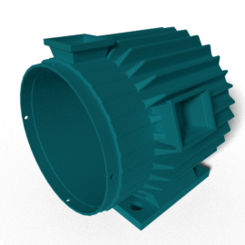

It is the outer part of the **three-phase induction motor**. Its main function is to support the stator core and the field winding. It acts as a covering, and it provides protection and mechanical strength to all the inner parts of the induction motor. The frame is either made up of die-cast or fabricated steel. The frame of three phase induction motor should be strong and rigid as the air gap length of three phase induction motor is very small. Otherwise, the rotor will not remain concentric with the stator, which will give rise to an unbalanced magnetic pull

**Stator Core:**

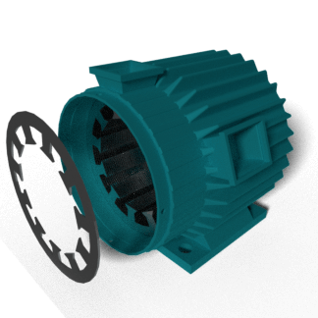

The main function of the stator core is to carry the alternating flux. In order to reduce the [eddy current](https://www.electrical4u.com/hysteresis-eddy-current-iron-or-core-losses-and-copper-loss-in-transformer/) loss, the stator core is laminated. These laminated types of structure are made up of stamping which is about 0.4 to 0.5 mm thick. All the stamping are stamped together to form stator core, which is then housed in stator frame. The stamping is made up of silicon steel, which helps to reduce the [hysteresis loss](https://www.electrical4u.com/hysteresis-eddy-current-iron-or-core-losses-and-copper-loss-in-transformer/) occurring in the motor.

**Stator Winding or Field Winding:**

The slots on the periphery of the stator core of the three-phase induction motor carry three phase windings. We apply three phase ac supply to this three-phase winding. The three phases of the winding are connected either in star or delta depending upon which type of starting method we use. We start the squirrel cage motor mostly with star-delta stator and hence the stator of squirrel cage motor is delta connected. We start the slip ring three-phase induction motor by inserting [resistances](https://www.electrical4u.com/electrical-resistance-and-laws-of-resistance/) so, the stator winding of slip ring induction motor can be connected either in star or delta. The winding wound on the stator of three phase induction motor is also called field winding, and when this winding is excited by three phase ac supply, it produces a rotating magnetic field.  
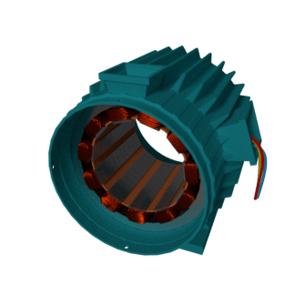

**Types of Three Phase Induction Motor:**

**1.Squirrel Cage Three Phase Induction Motor**

The rotor of the squirrel cage three phase induction motor is cylindrical and have slots on its periphery. The slots are not made parallel to each other but are bit skewed (skewing is not shown in the figure of squirrel cage rotor besides) as the skewing prevents magnetic locking of stator and rotor teeth and makes the working of the motor more smooth and quieter. The squirrel cage rotor consists of aluminium, brass or copper bars (copper bras rotor is shown in the figure beside). These aluminium, brass or copper bars are called rotor conductors and are placed in the slots on the periphery of the rotor. The rotor conductors are permanently shorted by the copper, or aluminium rings called the end rings. To provide mechanical strength, these rotor conductors are braced to the end ring and hence form a complete closed circuit resembling like a cage and hence got its name as squirrel cage induction motor. The squirrel cage rotor winding is made symmetrical. As end rings permanently short the bars, the rotor resistance is quite small, and it is not possible to add external resistance as the bars get permanently shorted. The absence of slip ring and brushes make the construction of Squirrel cage three-phase induction motor very simple and robust and hence widely used three phase induction motor. These motors have the advantage of adopting any number of pole pairs. The below diagram shows a squirrel cage induction rotor having aluminium bars short circuit by aluminium end rings.

**Advantages of Squirrel Cage Induction Rotor**

1. Its construction is very simple and rugged.
2. As there are no brushes and slip ring, these motors requires less maintenance.

**Applications of Squirrel Cage Induction Rotor**

We use the squirrel cage induction motors in lathes, drilling machine, fan, blower printing machines, etc

**2. Slip Ring or Wound Rotor Three Phase Induction Motor:**

In this type of three phase induction motor the rotor is wound for the same number of poles as that of the stator, but it has less number of slots and has fewer turns per phase of a heavier conductor. The rotor also carries star or delta winding similar to that of the stator winding.

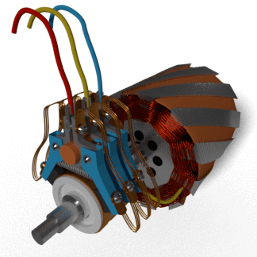

The rotor consists of numbers of slots and rotor winding are placed inside these slots. The three end terminals are connected together to form a star connection. As its name indicates, three phase slip ring induction motor consists of slip rings connected on the same shaft as that of the rotor.

The three ends of three-phase windings are permanently connected to these slip rings. The external resistance can be easily connected through the brushes and slip rings and hence used for speed controlling and improving the starting [torque of three phase induction motor](https://www.electrical4u.com/torque-equation-of-three-phase-induction-motor/). The brushes are used to carry [current](https://www.electrical4u.com/electric-current-and-theory-of-electricity/) to and from the rotor winding. These brushes are further connected to three phase star connected resistances. An electrical diagram of a slip ring three phase induction motor is shown below:

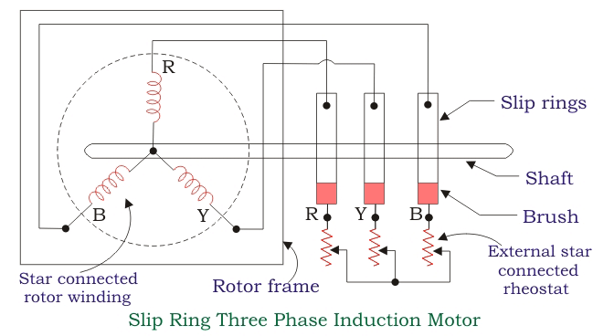

At starting, the resistance is connected to the rotor circuit and is gradually cut out as the rotor pick up its speed. When the motor is running the slip ring are shorted by connecting a metal collar, which connects all slip ring together, and the brushes are also removed. This reduces the wear and tear of the brushes. Due to the presence of slip rings and brushes the rotor construction becomes somewhat complicated therefore it is less used as compare to squirrel cage induction motor.

**Advantages of Slip Ring Induction Motor**

1. It has high starting torque and low starting current.
2. Possibility of adding additional resistance to control speed.

**Application of Slip Ring Induction Motor**

Slip ring induction motor are used where high starting torque is required i.e in hoists, cranes, elevator etc.

**Difference between Slip Ring and Squirrel Cage Induction Motor:**

|  |  |
| --- | --- |
| **Slip ring or phase wound Induction motor:** | **Squirrel cage induction motor:** |
| Construction is complicated due to presence of slip ring and brushes | Construction is very simple |
| The rotor winding is similar to the stator winding | The rotor consists of rotor bars which are permanently shorted with the help of end rings |
| We can easily add rotor resistance by using slip ring and brushes | Since the rotor bars are permanently shorted, its not possible to add external resistance |
| Due to presence of external resistance high starting torque can be obtained | Staring torque is low and cannot be improved |
| Slip ring and brushes are present | Slip ring and brushes are absent |
| Frequent maintenance is required due to presence of brushes | Less maintenance is required |
| The construction is complicated and the presence of brushes and slip ring makes the motor more costly | The construction is simple and robust and it is cheap as compared to slip ring induction motor |
| This motor is rarely used only 10% industry uses slip ring induction motor | Due to its simple construction and low cost. The squirrel cage induction motor is widely used |
| Rotor copper losses are high and hence less efficiency | Less rotor copper losses and hence high efficiency |
| Speed control by rotor resistance method is possible | Speed control by rotor resistance method is not possible |
| Slip ring induction motor are used where high starting torque is required i.e. in hoists, cranes, elevator etc | Squirrel cage induction motor is used in lathes, drilling machine, fan, blower printing machines etc |

Top of Form

**Want More Electrical Knowledge?**

Bottom of Form

Top of Form

Bottom of Form

Bottom of Form**Principle of operation**

The stator winding of a 3-phase induction motor is connected to 3-phase balanced supply. The flow of 3-phase currents in the 3-phase stator winding produces a rotating magnetic field as discussed in Art. 3.7. The speed of rotating field is the synchronous speed, $n_{s}=\frac{2f_{i}}{P}$ rps.

The rotating flux wave cuts the stationary rotor conductors P $×$ $n_{s}$ times per sec and therefore emfs induced in the rotor conductors. As the rotor circuit is short-circuited, these induced emfs give rise to current in the rotor conductors. The interaction of these rotor currents with rotating flux wave produces torque in the rotor of a 3-phase induction motor and as a consequence, rotor begins to rotate.

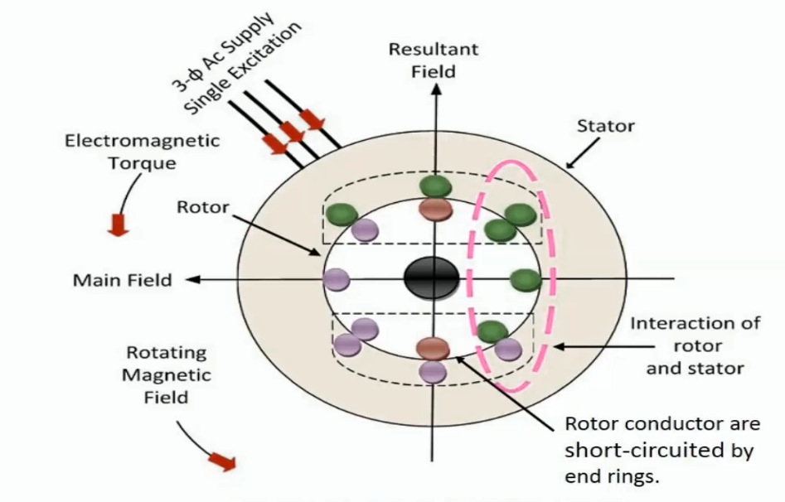

According to Lenz’s law, effect opposes the cause. Here, effect is the developed torque and cause is the flux-cutting by the rotor conductors. Therefore, as per Lenz’s law, the developed torque must oppose (or minimise) the cause, that is flux-cutting action. This is possible only if the developed torque forces the rotor to rotate in the direction of rotating field. When this happens, the relative speed between rotating flux and rotor conductors is reduced and therefore flux-cutting action (times per sec) also gets reduced. For example, if rotor speed is $n_{r}$ rps in the direction of rotating flux wave,

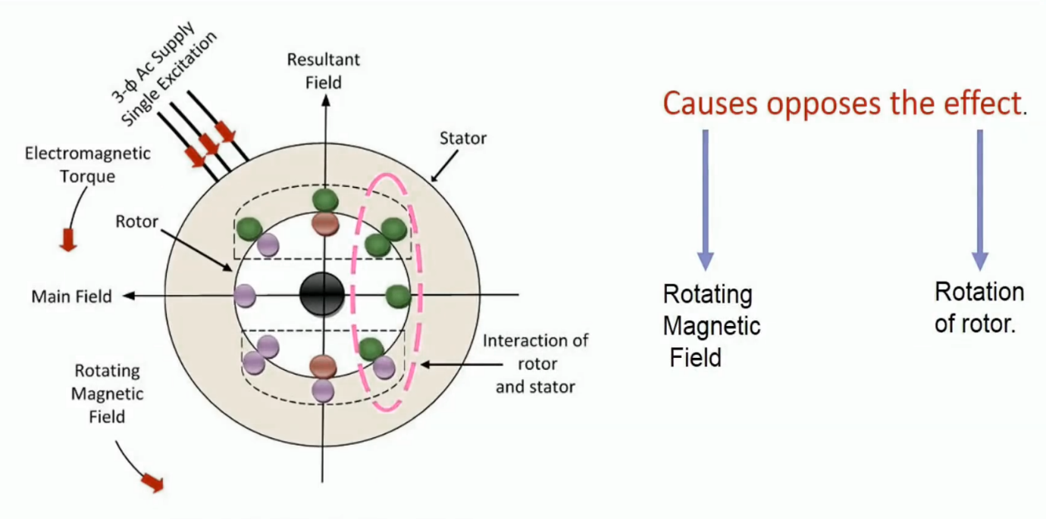

the relative speed between rotating flux wave and rotor conductors becomes $(n_{s }- n_{r})$ rps and the flux-cutting action reduces from P $×$ $n_{s}$ times per sec to P $×$ $(n_{s }- n_{r})$ times per sec as demanded by Lenz’s law. This shows that rotor must rotate in the direction of rotating magnetic field when 3-phase supply is given to stator of a 3-phase induction motor. If rotor is assumed to run at synchronous speed $n_{s }$ in the direction of rotating field, then there would be no flux-cutting action, no emf in rotor conductors, no current in rotor bars and therefore no developed torque. Thus, the rotor of 3-phase induction motor can never attain synchronous speed.

Torque equation of Three phase Induction Motor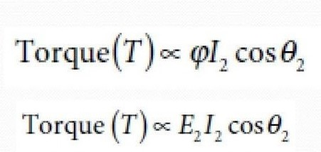

Torque equation of 3 phase induction motor in running condition:

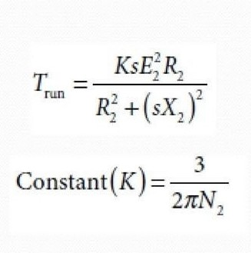

**DIFFERENT TYPES OF CHARACTERISTICS& EXPRESSION OF THREE PHASE INDUCTION MOTOR**

In a electric machines, a three-phase [induction machine](https://electricala2z.com/motors-control/types-single-phase-induction-motors-single-phase-induction-motor-wiring-diagram/) can work as a generator and as a motor. For this machine, however, because the stator must be connected to the three-phase circuit, the difference between being a motor or functioning as a generator lies in the speed of the rotor.

 In general, if the rotor speed is higher than the synchronous speed, then it behaves as a **generator**, and if the rotor speed is less than the synchronous speed, it becomes a **motor**.

The synchronous speed is determined by the line frequency and the number of poles of the stator winding.The developed rotating magnetic field, after the stator is electrically connected, revolves at the synchronous speed. This causes the rotor to follow the rotating magnetic field and rotate (thus, a motor), but, if the rotor shaft is given mechanical energy to rotate faster than the speed of the magnetic field, then the machine behaves as a generator.

The curve consists of two almost symmetrical curves, one representing the **induction** **motor operation** and one associated with the **generator operation**. This curve can be shown differently (swapping the coordinates) or can be continued from motor side for other characteristics (such as dynamic braking, where the direction of the developed torque is to the opposite of rotation, thus, a braking action), but here we are only interested in the following information that can be observed **from the curve**:

* Figure 1 Torque-speed(slip) characteristic curve of a three-phase induction motor & generator.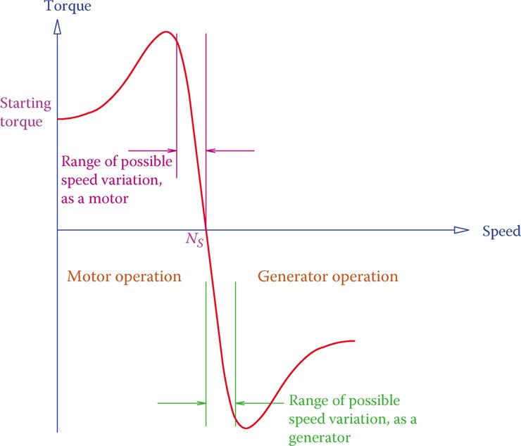
* If the rotor speed is less than the synchronous speed (NS), the machine acts as a motor; it delivers torque to a load. The number of torque changes based on a given speed of the load.
* The only part of the curve, which is almost linear, is good for operation. For both functions, as a motor and as a generator, outside of this linear segment is not suitable for operating the machine.
* As a motor, the machine has a starting torque (at zero speed); thus, the machine is a self-starter.
* In the linear (operating) region as a motor, as torque increases, the speed decreases, and vice versa. At the synchronous speed NS, no torque can be delivered by the motor.
* Within the linear region as a generator, if speed is increased, torque demand also increases, and vice versa. This is a self-regulatory behavior; it prevents a machine from going into a runaway state.
* If the machine runs at a speed equal to NS, it does not produce any power (because the torque is zero at this point, and power = torque × speed).

The above observations imply that as a motor the speed is always less than the synchronous speed, and as a generator, the machine must always be run above the synchronous speed.

Except in a particular mode, many wind turbines used an induction generator. This is an intelligent choice because the variable wind speed can move the operating point of an [induction generator](http://electricalacademia.com/induction-motor/induction-generator-types-working-principle-permanent-magnet-generator-working-principle/) along the linear portion of the generator characteristic curve. In this way, with higher wind speeds a generator turns faster and produces more power without affecting the synchronous speed.

The curve depicted in **Figure 1** has a typical shape. The exact form of the curve depends on the physical properties of each individual machine, including the resistance in the windings and the external circuit for a WRIM.

The difference between the speed of the rotating magnetic field (the synchronous speed) and the rotor speed is called the **slip speed**, and the ratio of this difference to the synchronous speed is called **slip**.

The magnitude of slip, expressed in percentage, is usually small, say below 3 percent. It can be determined from

**Slip speed:** Difference between the speeds of the rotor and the rotating magnetic field in an AC induction machine.

**Slip:** The fact that the rotor of an induction machine does not rotate with the same speed as the rotating magnetic field (turning faster in a generator and slower in a motor).

S = (NS - N)/NS = 1 - NS/N …….(1)

Where NS is the synchronous speed and N is the rotor speed. For a generator NS < N and, thus, S becomes negative. Note, that as a generator, no matter how much N is larger than NS the frequency of the electricity injected into the AC line is NS.

The rotational speed N of an induction motor, and thus the slip, depends on the operating point, which depends on a load torque requirement (so, for a motor, if torque is higher, speed is lower). The same is true for a **generator**; an equilibrium point is reached when the torque demand on the shaft is fulfilled by the generator prime mover.

**EXPRESSION OF TORQUE SPEED CHARACTERISTICS**

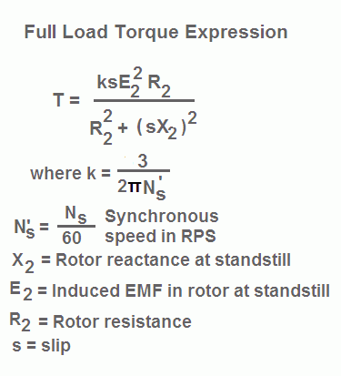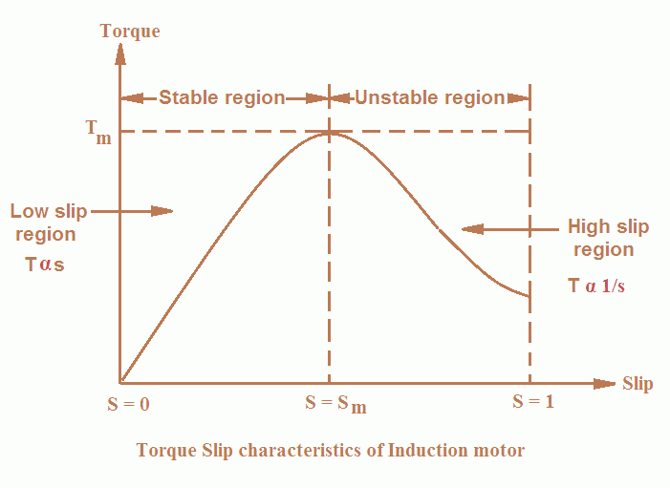  
To draw the **torque slip characteristics of induction motor** (three phase) following points are considered:

* At synchronous speed (Ns); slip, s = 0 and torque, T = 0.
* When rotor speed is very near to synchronous speed i.e. when the slip is very low the value of the term (sX2)2 is very small in comparison to R22 and is neglected. Therefore, torque is given by the expression:  
  **T = ksE22R2 / R22**In the above expression, all quantities are constant except slip s.
* Therefore, **T α s**.
* Thus,**at low values of slip, torque is approximately proportional to slip** s **and the torque slip characteristics of induction motor is a straight line as shown in the figure.**
* **The region (from s = 0 to s = sm) is called the stable region of operation and operating point of the motor should be in this region.**  
  In the stable region, the value of slip is small. Hence this region is also called as the low slip region.

•As the slip increases torque increases and attains its maximum value when **s = R2/X2**. This maximum value of torque is also known as break down or pull out torque.When a further increase in [slip](https://www.yourelectricalguide.com/2017/07/induction-motor-slip.html) occurs due to increase in load beyond the point maximum torque i.e. when slip is high, the value of term **(sX2)2** is very large in comparison to R22.

 Therefore, R22 is neglected as compare to (sX2)2 and torque is given by the expression:

**T = ksE22R2 / (sX2)2  
 or T = kE22R2 / (sX22)**  
 In the above expression, all quantities are constant except s.

Therefore, **T α 1/s**   
**Thus at higher values of slip (i.e. the slip beyond that corresponding to maximum torque) torque is approximately inversely proportional to slip, s and the torque slip characteristics of induction motor is rectangular hyperbola as shown in the figure.**  
   
**The region (extending from s = sm to s = 1) is called unstable region. In this region with the increase in load, slip increases but torque decreases.  
   
The result is that the motor could not pick up the load and slows down and eventually stops.** In the unstable region, the value of slip is large so this region is also called as the high-slip region.

## Torque Slip Characteristics of Three Phase Induction Motor

The torque slip curve for an [induction motor](https://www.electrical4u.com/induction-motor-types-of-induction-motor/) gives us the information about the variation of torque with the slip. The slip is defined as the ratio of difference of synchronous speed and actual rotor speed to the synchronous speed of the machine. The variation of slip can be obtained with the variation of speed that is when speed varies the slip will also vary and the torque corresponding to that speed will also vary.

The curve can be described in three modes of operation-

1) **Motoring mode**

**2) Generating mode**

**3) Braking mode**

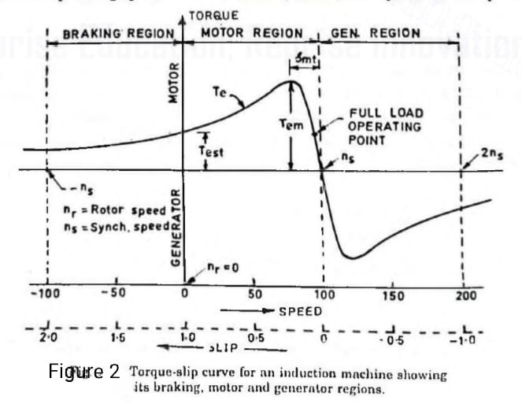

**MOTORING MODE :**

**In this mode of operation, supply is given to the stator sides and the motor always rotates below the synchronous speed. The induction motor torque varies from zero to full load torque as the slip varies. The slip varies from zero to one. It is zero at no load and one at standstill. From the curve it is seen that the torque is directly proportional to the slip.**

**That is, more is the slip, more will be the torque produced and vice-versa. The linear relationship simplifies the calculation of motor parameter to great extent.**

**GENERATING MODE :**

In this mode of operation induction motor runs above the synchronous speed and it should be driven by a prime mover. The stator winding is connected to a three phase supply in which it supplies electrical energy. Actually, in this case, the torque and slip both are negative so the motor receives mechanical energy and delivers electrical energy. Induction motor is not much used as generator because it requires reactive power for its operation.  
That is, reactive power should be supplied from outside and if it runs below the synchronous speed by any means, it consumes electrical energy rather than giving it at the output. So, as far as possible, [induction generators](https://www.electrical4u.com/induction-generator/) are generally avoided.

BRAKING MODE **:**

In the Braking mode, the two leads or the polarity of the supply[voltage](https://www.electrical4u.com/voltage-or-electric-potential-difference/) is changed so that the motor starts to rotate in the reverse direction and as a result the motor stops. This method is used when it is required to stop the motor within a very short period of time. The kinetic energy stored in the revolving load is dissipated as heat. Also, motor is still receiving power from the stator which is also dissipated as heat. So as a result of which motor develops enormous heat energy. For this stator is disconnected from the supply before motor enters the braking mode.  
If load which the motor drives accelerates the motor in the same direction as the motor is rotating, the speed of the motor may increase more than synchronous speed. In this case, it acts as an [induction generator](https://www.electrical4u.com/induction-generator/) which supplies electrical energy to the mains which tends to slow down the motor to its synchronous speed, in this case the motor stops. This type of breaking principle is called dynamic or regenerative breaking.

**Slip Speed Control**

1. When the motor is operated below the base speed :-

Let *V* and *f* denote the rated voltage and frequency of the machine. When the motor is operated below the base speed with constant (*V/f*) control, for a frequency, *kf*, the terminal voltage will be *KV*, where *k* is a factor such that, $0≤k≤1$. Thus, as frequency is changed from 0 to *f, k* changes from 0 to 1 and voltage changes from 0 to *V*.

Substituting for voltage *kV* and for frequency *kf* and neglecting stator resistance drop.

|  |  |
| --- | --- |
| $$I_{r}= \frac{V}{\sqrt{{({R^{'}}_{r}l ks)}^{2}+{({X^{'}}_{s}+{X^{'}}_{r} )}^{2}}}$$ |  |
| $$T=\frac{3}{ω_{ms}}\left[\frac{V^{2}{R^{'}}_{r}l ks}{{({R^{'}}_{r}l ks)}^{2}+{({X^{'}}_{s}+{X^{'}}_{r} )}^{2}}\right]$$ |  |

if (*ks*) is maintained constant as *k* is varied, then rotor current ${I^{'}}_{r}$ and torque *T* will remain constant. Since the slip is small ${I^{'}}_{r}$ will be in phase with voltage. Since flux is constant $I_{m}$ will also be constant. Now

$I_{s}=\sqrt{{I^{'}}_{r}+I_{m}^{2}}$ = constant

Thus, if the motor operation is carried out at constant value of *ks* as the frequency is varied then the motor will operate at a constant current and torque. Let us examine the meaning of *ks*.

At frequency *kf*,

Synchronous speed = ${kω}_{ms}$

Slip $s= \frac{{kω}_{ms}-ω_{m}}{{kω}_{ms}}$

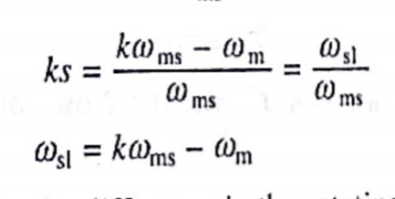

and,

Where

Note $ω_{sl}$ is the slip speed, which is difference in the difference in the rotating field speed ${kω}_{ms}$ and rotor speed $ω_{m}$. It is also the drop in motor speed from its no load speed, when the machine is loaded.

The above discussion shows that for any value of *T1*the drop in the motor speed from its no load speed (${kω}_{ms}$) is the same for all frequencies. Hence, machine speed torque characteristics for $0<s{<s}_{m}$ are approximately parallel curves.

Operation of the machine at a constant slip speed also implies the operation at a constant rotor frequency as shown below.

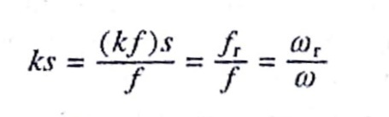

Where $f_{r}$ and $ω_{r}$ rotor frequency in Hz and rad/sec, respectively.

For $s{<s}_{m}$, $\left({R^{'}}_{r}l ks\right)≫({X^{'}}_{s}+{X^{'}}_{r} )$, Hence from

2. Consider the operation above base speed :-

As stated earlier, machine operates at a constant voltage V .

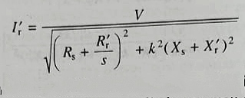

As, the frequency is higher than the rated k>1. Since, the operation is again constrained between the synchronous speed and the maximum torque, slip has a small value, hence

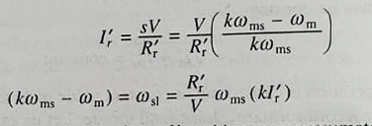

Thus for speed above the base speed, at a given Ir` and hence approximately at a given Is, the slip speed **ωsl**  increases linearly with k (or frequency). This behaviour is utilized in close-loop speed control for limiting the current within permissible value above base speed.

Since, the slip is small, Ir` is in phase with V. If the machine copper loss is neglected, the developed power Pm is given by,

Pm = 3VIr`

Consequently, Pm is constant for a given Ir`, and therefore for a given Is. The drive, theref0re, operates in constant power mode.

Speed Control of three phase induction motor

Speed Control of three phase induction motor can be done by Different method.

Here we are going to discuss about V/F control method of speed control.

Method 1:(f<fbase and V/F=constant)

V/f= constant => v proportional to F

* STmax =R2/X2 => STmax $∝$ X2

$↑$ STmax $∝$ 1/f $↓$ [X $2∝$ f ]

2.Tmax=3/2 $ω*$ V^2/X2 =>Tmax $∝$ 1/f *f^2/f

[v $∝$ f ; X $∝$ f; $ω$ s $∝$ f ]

Tmax=constant

3. Tst =3/s*R2V^2(X2)^2 $→$ Tst 1/f * f^2/f^2

Tst 1/f

4. Ns=120*f/p

5. Ns-Nr sf

We know, equation of toque

Td =3/ $ω$ s $\frac{\text{V^2.R2/S }}{\text{(R2/S)^2..X2^2 }}$

*

for low slip region, R2/S >>X2

Td=3/ $ωs$*SV^2

Now for constant torque,

$\frac{\text{S1V1 }}{f\text{1 }}$ = $\frac{\text{S2V2^2 }}{f\text{2 }}$

S1 $f$ 1=s2V2

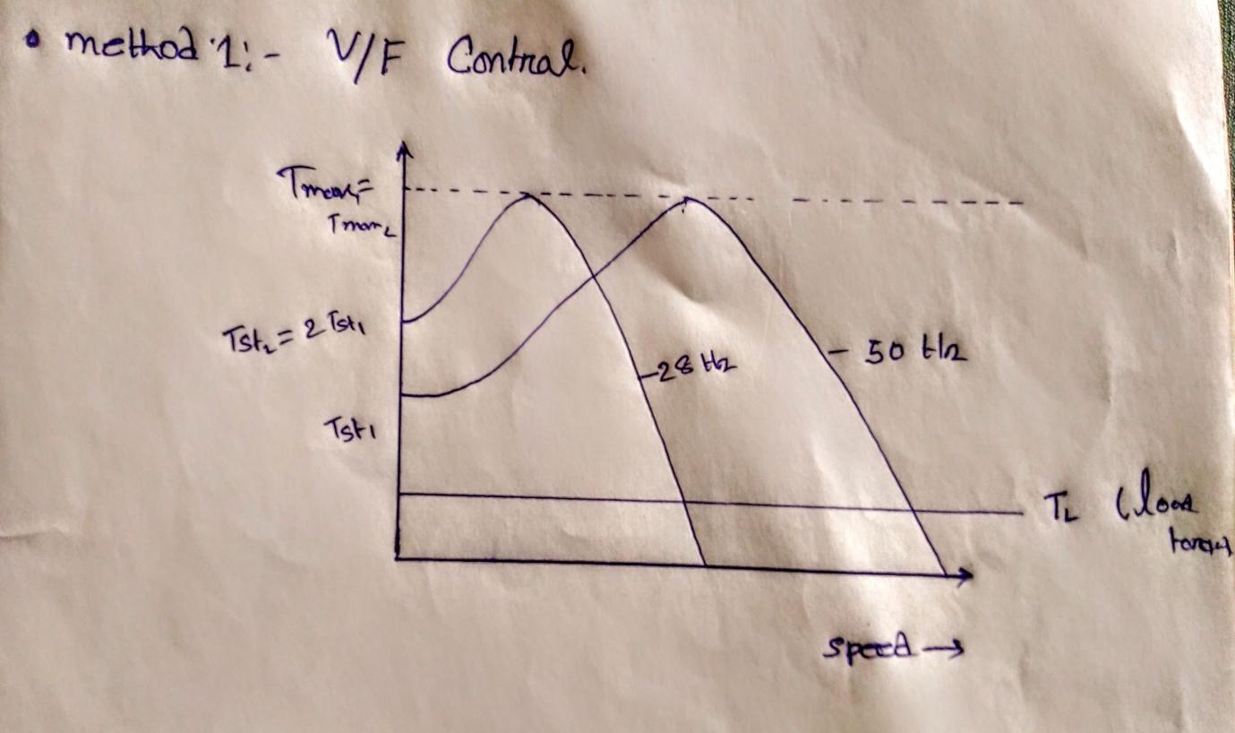

Constant voltage ad variable frequency.

(It is useful for f >=fbase )

V/f != constant, $φ !$ = constant,Im !=constant.

If f $↑ →$ $φ↓$ $→$ I $m↑$ V=constant,f=variable.

1. Ns=120*f/p Ns

2. Tmax X2=

=>max

3. Stmax = R2/X2 =>S Tmax

4. Tst = =>Tst $↓$ $∝\frac{1}{\text{f^}\text{3}↑}$

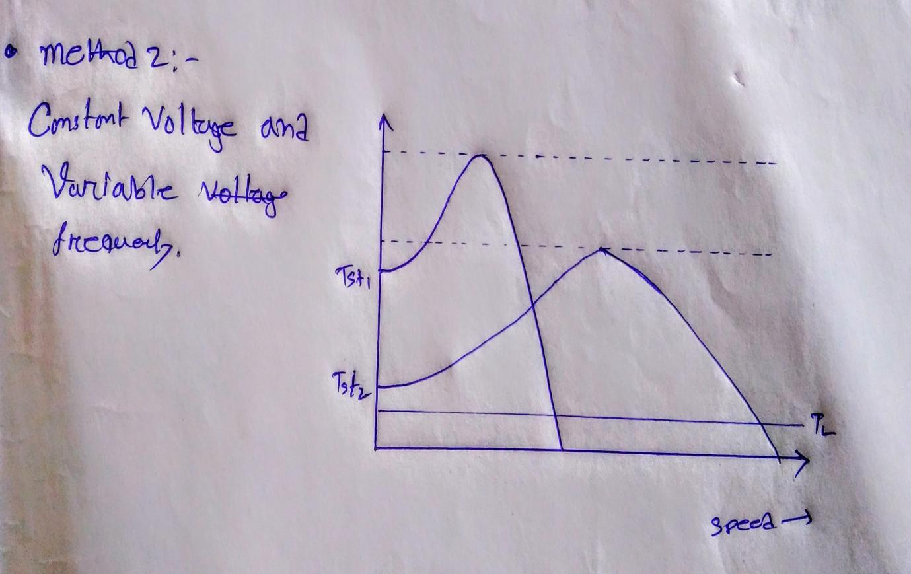

2.

POWER ELECTRONICS

**POWER DIODES : -**

* **BASIC STRUCTURE OF POWER DIODES : -**

Power diode differ in structure from signal diodes. A signal diode constitutes a simple $p$- $n$ junction. The intricacies in constructing power diodes arise from the need to make them suitable for high-voltage and high-current and a large reverse breakdown voltage.

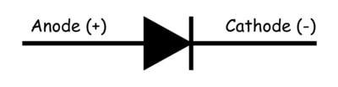

Symbol

It consists of heavily doped $n^{+}$ substrate. On this substrate, a lightly doped $n^{-}$ layer is epitaxially grown. Now a heavily doped $p^{+}$ layer is diffused into $n^{-}$ layer to form the anode of power diode. This shows that $n^{-}$ layer is the basic structural feature not found in signal diodes. The function of $n^{-}$ layer is to absorb the depletion layer of the reverse biased $p^{+}n^{-}$ junction $J_{1}$. The breakdown voltage needed in a power diode governs the thickness of $n^{-}$ layer; greater the breakdown voltage, more the $n^{-}$ layer thickness. This $n^{-}$ layer is lightly doped, nearly intrinsic. Because of this reason, $n^{-}$ layer is sometimes called $i$- $layer$ and the device as $p$- $i$- $n$ diode or PiN diode.

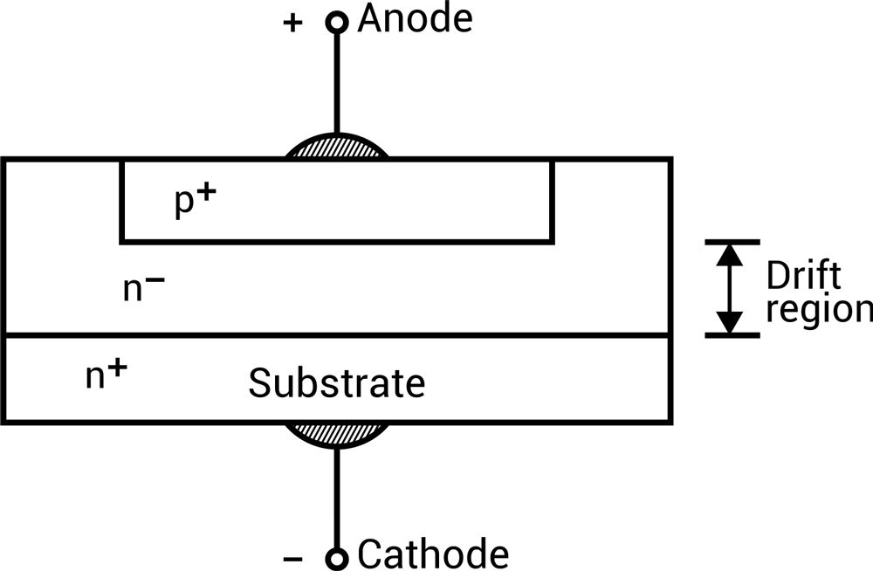

Structure

* CHARACTERISTICS OF POWER DIODES : -

1. I-V CHARACTERISTICS : -
2. Anode (+ve),Cathode (-ve) –

Diode is said to be Forward Biased. In cut-in voltage (Threshold Voltage) it conduct. For Diodes current increases, first exponentially with voltage and then becomes almost linear. For Power Diodes hide the exponential part of i-v curve. Cause :-

The high magnitude of current, leads to ohmic drops and n- region forms a considerable drop in the ohmic resistance.

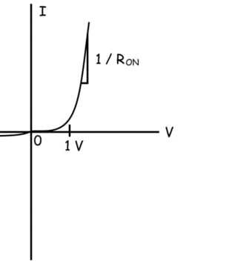

Forward Voltage Drop

1. Anode (-ve) and Cathode (+ve) –

Diode is said to Reverse Biased. A small reverse (Leakage) current flow. Large Vbd increase Current, and current increase Power Loss, and for this cause high heat generate and chance the Diode destroy.

So, Power Diode must be avoided by operating it below the specific Peak Reverse Repetitive Voltage (Vrrm).

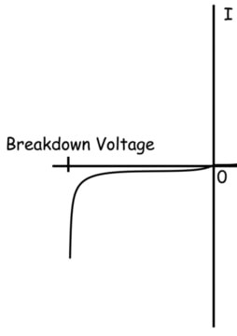

Vrr

1. DIODE REVERSE RECOVERY CHARACTERISTICS : -

After the forward diode current decays to zero, the diode continues to conduct in the reverse direction because of the presence of stored charges in the depletion region and the semiconductor layers. The reverse current flows for a time called reverse recovery time $t_{rr}$. The diode regains its blocking capability until reverse recovery current decays to zero. The reverse recovery time $t_{rr}$ is defined as the time between the instant forward diode current becomes zero and the instant reverse recovery current decays to 25% of its reverse peak value $I_{RM}$.

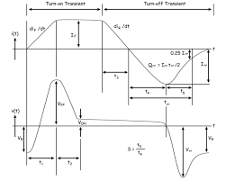

Power Diode Reverse Recovery Characteristics

* REVERSE RECOVERY TIME (trr) CALCULATION : -

Peak Inverse Current IRM :-

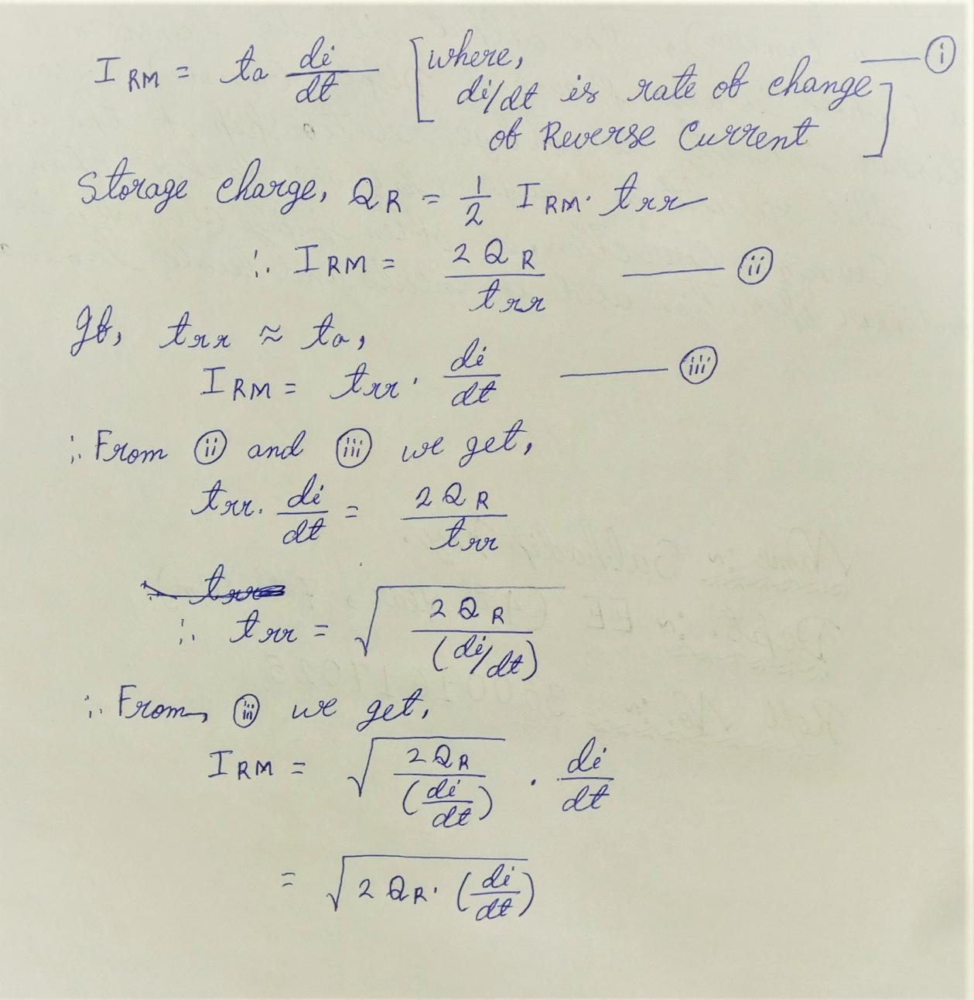

TYPES OF DIODES : -

1. General Purpose Diode –

* High reverse recovery time .
* Current vary form 1 – 1000 A .
* Voltage ratings form 50 – 5k v .
* Use – Battery Charging , Electroplating , Welding .

1. Fast Recovery Diode –

* Low reverse recovery time .
* Current 1 – 1k A .
* Voltage 50 – 3k V .
* V<400 – First recovery time as low as 50n S .
* V>400 – In order to shorten the Reverse Recovery time , platinum & gold doping is carried out .

1. Schottky Diode –

* Use metal is aluminium and semiconductor is silicon .
* Reverse recovery time is nil .
* Switching is very fast .

Switching is not effected by temperature variation .

***IGBT:***

An insulated-gate bipolar transistor (IGBT) is a three-terminal power semiconductor device primarily used as an electronic switch, which, as it was developed, came to combine high efficiency and fast switching. It consists of four alternating layers (P–N–P–N) that are controlled by a metal–oxide–semiconductor (MOS) gate structure.

***Device structure:***

An IGBT cell is constructed similarly to a n-channel vertical-construction power MOSFET, except the n+ drain is replaced with a p+ collector layer, thus forming a vertical PNP bipolar junction transistor. This additional p+ region creates a cascade connection of a PNP bipolar junction transistor with the surface n-channel MOSFET.

***Cross-section of a IGBT:***

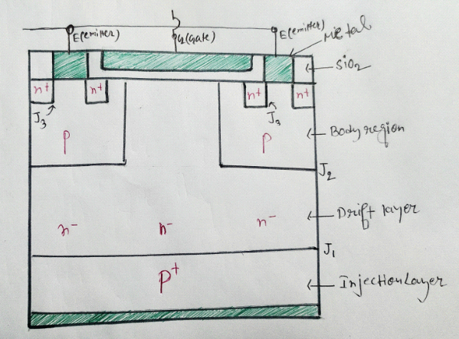

As Gate is isolated through sio2 layer so no current flow through gate terminal.

***Symbol of igbt:***

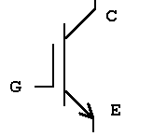

As gate is isolateted by **sio2**layer. So no current flows through gate terminal like MOSFET. So gate terminal is shown isolated in symbol of IGBT.

***Advantage of IGBT:***

As IGBT is best combination of BJT and MOSFET And as BJT has low ON state power drop and MOSFET has high input resistance. And as MOSFET is connected input of IGBT so IGBT has high input resistance and as BJT is connected to output of IGBT has low output ON state power drop.

***Equivalent circuit of IGBT:***

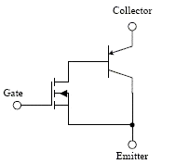

***Working principle of IGBT:***

***1.Connecting voltage accross C-E terminal:***

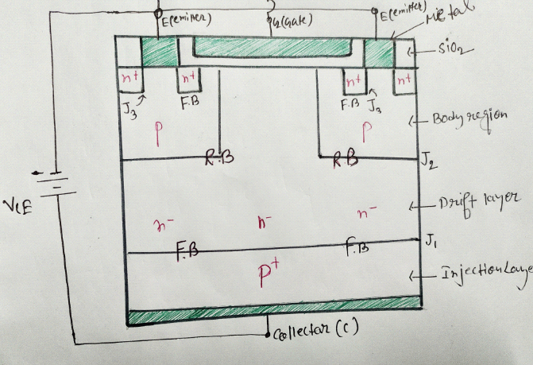

As we see positive terminal of battery VGE is connceted to Gate terminal and because of this some positive charges are accumulated to gate terminal. As we know minority charges of P substrate is free electrons. The accumulated positive charges in gate terminal attracted the free electrons of P substrate and this free electrons gets accumulated near the n+ reagion , shown in the above pic.

More we increase the value of VGE more free electrons gets accumulated near the n+ region. After a certain value of VGE ( threshold voltage) enough amount of free electron get accumulated so that a path is created through the accumulated free electron region and current flow from collector to emitter. Corrosponding path of flow of current is shown is the fig.

So when VGE =0 ,then no current flow from collector to emitter. And IGBT remains in cut off region.

More we increase the value of VGE =0 more current flow through collector to emitter.

***Transfer characteristics of IGBT:***

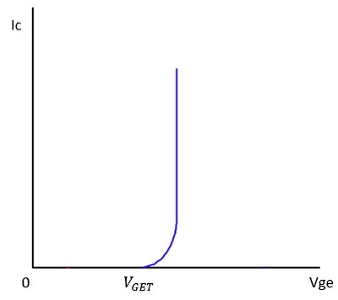

***Output characteristics of IGBT:***

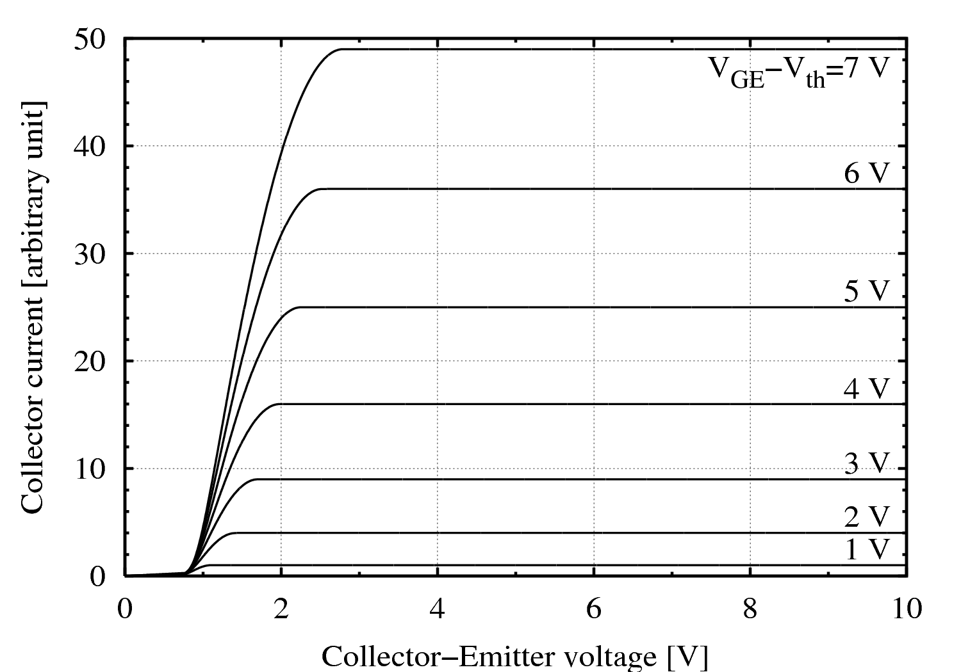

As we see whether current will flow or not/ IGBT will operate or not or in which region IGBT will work depends on value of VGE.

**SO WE CAN CONCLUDE THAT IGBT IS A VOLTAGE CONTROL DEVICE.**

***IGBT as switch:***

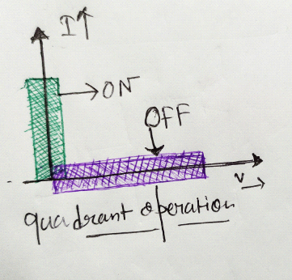

IGBT is a two quadrant device.

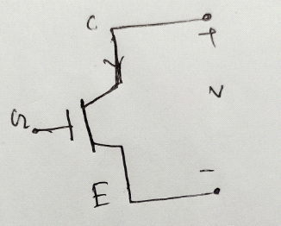

Terminals of VCE battery is shown. Here we only consider positive value of V in case of switching operation or quadrant operation as only in case of positive value of V the IGBT can operate as switch or get transition from ON state to OFF state.

***Quadrant I :***In ON state the positive VCE voltage is applied and corrospondingly positive VGE (considering threshold voltage = 0) is also applied. So IGBT gets ON and gets short circuited and corrosponding current flows.

***Quadrant II :*** In OFF state the positive VCE voltage is applied and give VGE=0 ( to off the IGBT or to operate IGBT in cut off region ). So IGBT gets opened and block positive VCE voltage.

**SINGLE PHASE VOLTAGE SOURCE INVERTER & FOURIER SERIES ANALYSIS**

**INTRODUCTION:**

Within the last decade, there have been major advancements in power electronics. Power electronics have moved along with these developments with such things as digital signal processors being used to control power systems. An Inverter is basically a converter that converts **DC-AC power**. Inverter circuits can be very complex so the objective of this paper is to present some of the inner workings of inverters without getting lost in some of the fine details. A voltage source inverter (VSI) is one that takes in a fixed voltage from a device, such as a dc power supply, and converts it to a variable-frequency AC supply. Voltage-source inverters are divided into three general categories: Pulse-width Modulated (PWM) Inverters, Square-wave Inverters, and Single-phase Inverters with Voltage Cancellation. Pulse-width modulation inverters take in a constant dc voltage. Diode-rectifiers are used to rectify the line voltage, and the inverter must control the magnitude and the frequency of the ac output voltages. To do this the inverter uses pulse-width modulation using its switches. There are different methods for doing the pulse-width modulation in an inverter in order to shape the output ac voltages to be very close to a sine wave. These different methods will be discussed further with a focus on sinusoidal PWM. Square-wave inverters have their input connected to a controlled dc voltage in order to control the magnitude of the output ac voltage. The inverter only controls the frequency of the output where the input voltage is controlled the magnitude. The output ac voltage has a waveform similar to a square wave which is where the inverter got its name. Lastly, Single-phase inverters with voltage cancellation take in a constant dc source and output a square-wave like ac voltage. They can control both the frequency and the magnitude of the output but do not use PWM and therefore have a square-wave like output. These inverters have combined characteristics of the previous two inverters. The voltage cancellation only works with single phase inverters, not three phase, this will be explained more further later on in the paper. Switch-mode dc-to-ac inverters are used in ac-motor drives and uninterruptible ac power supplies where the main objective is to provide a sinusoidal ac output where magnitude and frequency can both be controlled.

**CLASSIFICATION OF POWER ELECTRONIC DEVICES:**

* There are five main groups of power semiconductors. They are: power diodes, thyristors, power bipolar junction transistors (BJTs) , insulated gate bipolar transistors (IGBTS), and static induction transistors (SITs).

PRINCIPLE OF OPERATION (SAY HALF BRIDGE VSI)

* As the name implies,half-bridge inverter o/p varies from +Vs/2 to -Vs/2. In the circuit shown, two switching devices are connected in one common branch also called a leg. This switching may be SCR, MOSFET,or IGBT. Generally, we use MOSFET more commonly for high frequency applications.One more advantage with MOSFET is it has low switching losses but high conduction losses.

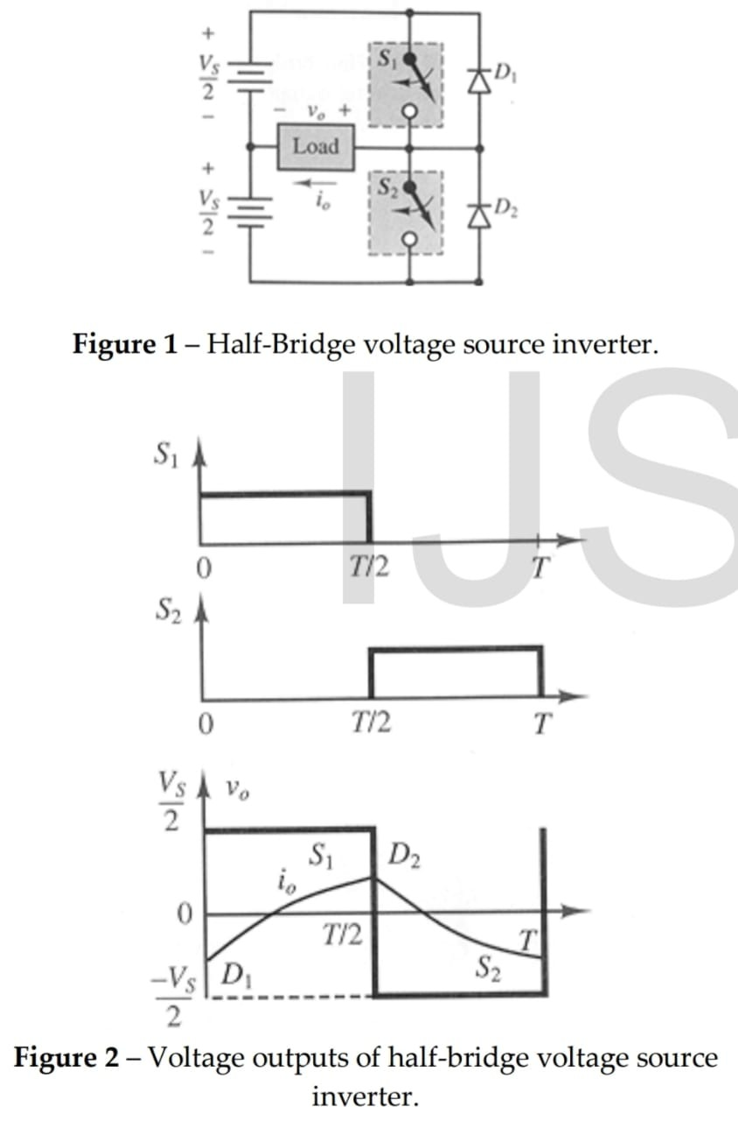

* Figure 1 shows a half-bridge voltage source inverter. The switches can be bipolar, MOS transistors, or thyristors. The circuit works by turning switch 1 on, the output voltage is then the positive half-cycle, meaning that it will be Vs/2. To get the negative half-cycle, switch 2 is turned on and switch 1 is turned off. The order of this is actually reversed, switch 1 must be turned off first in order to avoid any short circuit. Voltage outputs of this simple half-bridge inverter are shown in figure 2. If the load is always inductive, the load current, io, will lag the voltage waveform, also shown in figure 2. It is shown that the current is sometimes negative when the voltage is positive. The diodes function to conduct the load current whenever it is opposite polarity to that of the voltage. If the diodes were not present then the load current would not exist. Figure 2 also shows that D1 is conducting during the first half of the cycle and D2 during the second half.

## What is Single Phase Half-Bridge Inverter?

**Definition:** The inverter is a device that converts a dc voltage into ac voltage and it consists of four switches whereas half-bridge inverter requires two diodes and two switches which are connected in anti-parallel. The two switches are complementary switches which means when the first switch is ON the second switch will be OFF Similarly, when the second switch is ON the first switch will be OFF.

FOURIER ANALYSIS OF HALF BRIDGE

Using Fourier series,

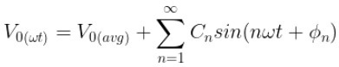

Where Cn, an and bn are

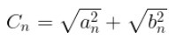 & 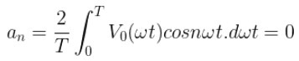

**bn=VS/nᴨ(1-cosnᴨ)**

The bn =0 when substituting even numbers (n=2,4,6…..) and bn =2Vs/nπ when substituting odd numbers (n=1,3,5……). Substitute bn =2Vs/nπ and an=0 in Cn will get Cn=2Vs/nπ.

**ϕn=tan-1(an/bn)=0**

**V01(ωt)=2 VS/ᴨ * (Sin** **ωt)**

Substitute V0 (avg) = 0  in will get

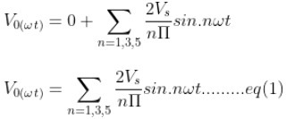

The equation (1) can also be written as

**V0(ωt)=2VS/ᴨ * (Sin** **ωt) + 2VS/3ᴨ * (Sin3ωt) +  2VS/5ᴨ * (Sin5ωt) +……..+∞**

**V0(ωt)= V01(ωt)+ V03(ωt)+ V05(ωt)**

The above expression is the output voltage which consists of fundamental voltage and odd harmonics. There are two methods to remove these harmonic components they are: to use the filter circuit and to use the pulse width modulation technique.

The fundamental voltage can be written as

**V01(ωt)=2VS/ᴨ * (Sin** **ωt)**

The maximum value of fundamental voltage

**V01(max) =2VS/ᴨ**

The RMS value of the fundamental voltage is

**V01(RMS) =2VS/√2ᴨ=√2VS/ᴨ**

The fundamental component of the RMS output current is

**I01(RMS)= V01(RMS)/R**

We have to obtain the distortion factor, the distortion factor is denoted by g.

g=**V01(RMS)/ V0(RMS)**= rms value of fundamental voltage/total RMS value of output voltage

By substituting the **V01(RMS)** and **V0(RMS)** values in g will get

**g=2√2/ ᴨ**

The total [harmonic distortion](https://www.elprocus.com/harmonic-distortion-types-and-its-causes/) is expressed as

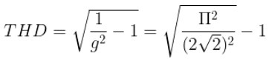

In the output voltage the total harmonic distortion THD=48.43%, but as per IEEE, the total harmonic distortion should be 5%.

The fundamental power output of single-phase bridge inverter is **P01= (V01(rms))2/R=I201(rms)R.**

By using the above formula we can calculate the fundamental power output.

In this way, we can calculate the various parameters of the single-phase half-bridge inverter.

## What is a Single Phase Full Bridge Inverter?

**Definition:** A full bridge single phase inverter is a switching device that generates a square wave AC output voltage on the application of DC input by adjusting the switch turning ON and OFF based on the appropriate switching sequence, where the output voltage generated is of the form +Vdc, -Vdc, Or 0.

FOURIER ANALYSIS OF FULL BRIDGE

Under Fourier series,

* **V0 (t) = ∑n=1,3,5α [ 4 VDC / nπ ] Sin n w0 t**
* **I0 (t) = ∑n=1,3,5α  [ 4 VDC / nπ l zn l  ] Sin n w0 t + φn**
* **V01max = 4 Vdc / π**
* **I01max = 4 Vdc / π Z1**
* **Mod Zn = R2 + ( n w0 L – 1/ n w0 C) ; where n = 1,2,3,4…..**
* **φn = tan -1 [ ( / R ]**
* Fundamental Displacement factor **FDF = cos φ**
* Diode current equation ID and waveform is given as follows
* **ID01 (avg) = 1/2π [ ∫0φ I01 max  Sin ( w0 t – φ1 ) ]dwt**
* **ID01 (rms) = [ 1/2π [ ∫0φ I012 max  Sin2 ( w0 t – φ1 ) dwt ] ]1/2**

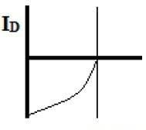fig.(I) D**iode Current Equation**

* Switch or thyristor current equation IT and waveform is given as follows
* **IT01 (avg) = 1/2π [ ∫φπ I01 max  Sin ( w0 t – φ1 ) ]dwt**
* **IT01 (rms) = [ 1/2π [ ∫φπ I012 max  Sin2 ( w0 t – φ1 ) dwt ] ]1/2**

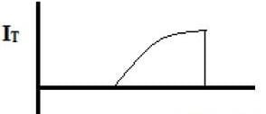

**Fig. (ii) Thyristor Wave form**

**Half Bridge Inverter**

**Circuit Diagram & Its Working**

The inverter is a power electronic converter that converts direct power to alternating power. By using this inverter device, we can convert fixed dc into variable ac power which as a variable frequency and voltage. Secondly from this inverter, we can vary the frequency i.e we will be able to generate the 40HZ, 50HZ, 60HZ frequencies as of our requirement. If the dc input is a voltage source then the inverter is known as VSI (Voltage Source Inverter). The inverters need four switching devices whereas half-bridge inverter needs two switching devices. The bridge inverters are of two types they are half-bridge [inverter](https://www.elprocus.com/multilevel-inverter-types-advantages/) and full-bridge inverter. This article discusses the half-bridge inverter.

**What is Half-Bridge Inverter?**

The inverter is a device that converts a dc voltage into ac voltage and it consists of four switches whereas half-bridge inverter requires two diodes and two switches which are connected in anti-parallel. The two switches are complementary switches which means when the first switch is ON the second switch will be OFF Similarly, when the second switch is ON the first switch will be OFF.

**Single Phase Half Bridge Inverter with Resistive Load**

The circuit diagram of a single-phase half-bridge inverter with resistive load is shown in the below figure.

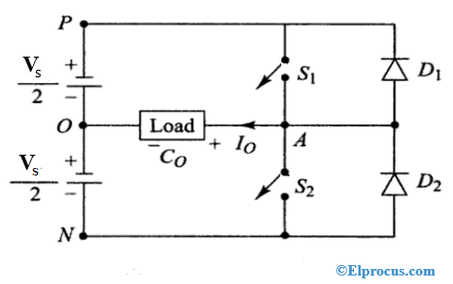

Half Bridge Inverter,

Where RL is the resistive load, Vs/2 is the voltage source, S1 and S2are the two switches, i0 is the current. Where each switch is connected to diodes D1and D2 parallelly. In the above figure, the switches S1 and S2are the self-commutating switches. The switch S1 will conduct when the voltage is positive and current is negative, switch S2will conduct when the voltage is negative, and the current is negative. The [diode](https://www.elprocus.com/types-of-diodes-and-applications/) D1will conduct when the voltage is positive and current is negative, diode D2 will conduct when the voltage is negative, and the current is positive.

**Case 1 (when switch S1is ON and S2is OFF):** When switch S1is ON from a time period of 0 to T/2, the diode D1and D2are in reverse bias condition and S2switch is OFF.

Applying KVL (Kirchhoff’s Voltage Law)

**Vs/2-V0=0**

Where output voltage V0= Vs/2

Where output current i0 = V0/R= Vs/2R

In case of supply current or switch current, the current iS1 = i0 = Vs/2R, iS2 = 0 and the diode current iD1 = iD2 = 0.

**Case 2 (when switch S2 is ON and S1is OFF)**: When switch S2is ON from a time period of T/2 to T, the diode D1and D2are in reverse bias condition and S1switch is OFF.

Applying KVL (Kirchhoff’s Voltage Law)

**Vs/2+V0=0**

Where output voltage V0= -Vs/2

Where output current i0 = V0/R= -Vs/2R

In case of supply current or switch current, the current iS1 = 0, iS2 = i0 = -Vs/2R and the diode current iD1 = iD2 = 0.

The single-phase half-bridge inverter output voltage waveform is shown in the below figure.

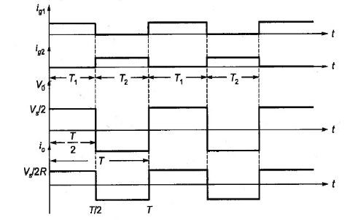

Half Bridge Inverter Output Voltage Waveform

The average value of output voltage is

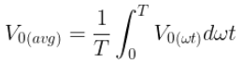

So output voltage waveform from converting time ‘T’ to ‘‘ωt” axis is shown in the below figure

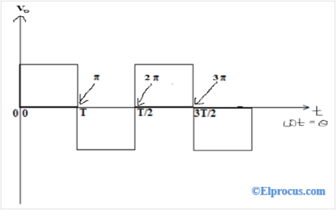

Converting Time Axis of the Output Voltage Waveform

When is multiply by zero, it will be zero; When is multiply by T/2, it will be T/2=π; When is multiply by T, it will be T=2π; When is multiply by 3T/2, it will be T/2=3π and so on. In this way, we can convert this time axis into the ‘ωt’ axis.

The average value of output voltage and output current is

**V0 (avg) = 0**

**I0 (avg) = 0**

The RMS value of output voltage and output current is

**V0 (RMS)= VS/2**

**I0 (RMS) = V0 (RMS) /R =VS/2R**

The output voltage we are getting in an inverter is not pure sinewave i.e a square wave. The output voltage with the fundamental component is shown in the below figure.

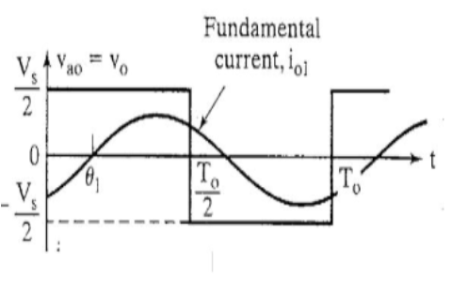

Output Voltage Waveform with Fundamental Component

Using Fourier series:

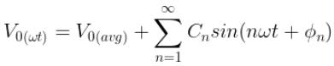

Where Cn, an and bnare

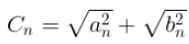

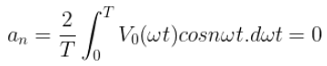

**bn=VS/nᴨ(1-cosnᴨ)**

The bn=0 when substituting even numbers (n=2,4,6…..) and bn=2Vs/nπ when substituting odd numbers (n=1,3,5……). Substitute bn=2Vs/nπ and an=0 in Cn will get Cn=2Vs/nπ.

**ϕn=tan-1(an/bn)=0**

**V01(ωt)=2 VS/ᴨ * (Sin** **ωt)**

Substitute V0 (avg) = 0  in will get

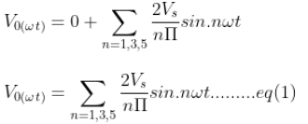

The equation (1) can also be written as

**V0(ωt)=2VS/ᴨ * (Sin** **ωt) + 2VS/3ᴨ * (Sin3ωt) +  2VS/5ᴨ * (Sin5ωt) +……..+∞**

**V0(ωt)= V01(ωt)+ V03(ωt)+ V05(ωt)**

The above expression is the output voltage which consists of fundamental voltage and odd harmonics. There are two methods to remove these harmonic components they are: to use the filter circuit and to use the pulse width modulation technique.

The fundamental voltage can be written as

**V01(ωt)=2VS/ᴨ * (Sin** **ωt)**

The maximum value of fundamental voltage

**V01(max)=2VS/ᴨ**

The RMS value of the fundamental voltage is

**V01(RMS)=2VS/√2ᴨ=√2VS/ᴨ**

The fundamental component of the RMS output current is

**I01(RMS)= V01(RMS)/R**

We have to obtain the distortion factor, the distortion factor is denoted by g.

g=**V01(RMS)/ V0(RMS)**=rms value of fundamental voltage/total RMS value of output voltage

By substituting the **V01(RMS)**and **V0(RMS)** values in g will get

**g=2√2/ ᴨ**

The total[harmonic distortion](https://www.elprocus.com/harmonic-distortion-types-and-its-causes/) is expressed as

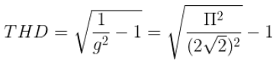

In the output voltage the total harmonic distortion THD=48.43%, but as per IEEE, the total harmonic distortion should be 5%.

The fundamental power output of single-phase bridge inverter is

**P01= (V01(rms))2/R=I201(rms)R**

By using the above formula, we can calculate the fundamental power output.

In this way, we can calculate the various parameters of the single-phase half-bridge inverter.

**Single Phase Half Bridge Inverter with R-L Load**

The circuit diagram of the R-L load is shown in the below figure.

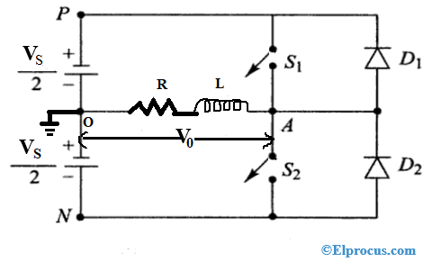

The circuit diagram of the single-phase half-bridge inverter with R-L load consists of two switches, two diodes, and voltage supply. The R-L load is connected between A point and O point, point A is always considered as positive and point O considered as negative. If the current flow from point A to O then the current will be considered as positive, similarly if the current flow from point to A then the current will be considered as negative.

In the case of R-L Load, the output current will be an exponential function to time and lags the output voltage by an angle.

**ϕ= tan-1(ωL/R)**

**Operation of Single-Phase Half Bridge Inverter with R- Load**

The working operation is based on the following time intervals

1. **Interval I (0<t<t1):**

 In this duration, both the switches are OFF and diode D2 is in reverse bias condition. In this interval, the inductor releases its energy through diode D1, and output current decreases exponentially from its negative max value (-Imax) to zero.

By applying KVL to this time interval will get

The output voltage V0>0; The output current flows in the reverse direction, therefore, i0<0; switch current iS1=0 and diode current iD1= -i0

1. **Interval II (t1<t<T/2):**

In this duration, the switch S1 and S2are closed and S2 is are OFF and both the diodes are in reverse bias condition. In this interval, the inductor starts to store the energy, and output current increases from zero to its positive max value (Imax).

Applying KVL will get

The output voltage V0>0; The output current flows in the forward direction, therefore, i0>0; switch current iS1= i0and diode current iD1= 0

1. **Interval III (T/2<t<t2):**

 In this duration, both the switch S1 and S2are OFF and the diode D1 is in reverse bias and D2is in forwarding bias are in reverse bias condition. In this interval, the inductor releases its energy through diode D2. The output current decreases exponentially from its positive max value (Imax) to zero.

Applying KVL will get

The output voltage V0<0; The output current flows in the forward direction, therefore, i0>0; switch current iS1= 0 and diode current iD1= 0

1. **Interval IV (t2 <t<T):**

 In this duration, the switch S1 is OFF and S2are closed and the diodes D1 and D2are in reverse bias. In this interval, the inductor charged to negative max value (-Imax) to zero.

Applying KVL will get

The output voltage V0<0; The output current flows in the opposite/reverse direction therefore i0<0; switch current iS1= 0 and diode current iD1= 0

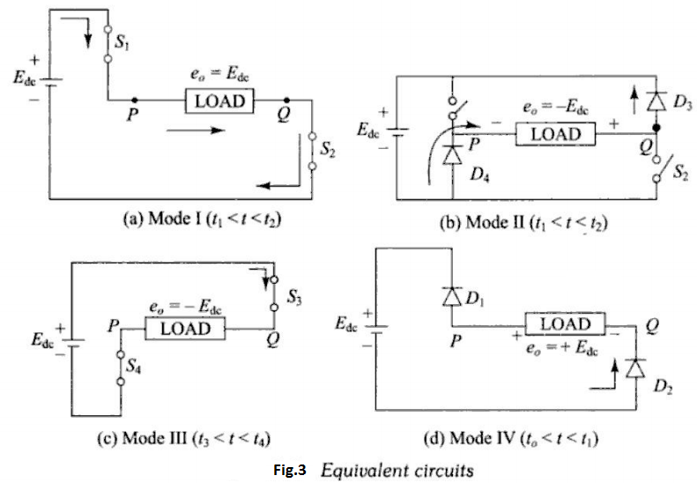

Operating Modes of Half Bridge Inverter

Summarization of the time intervals is shown in a below table

|  |  |  |  |  |  |  |
| --- | --- | --- | --- | --- | --- | --- |
| **S.NO** | **Time**  **Interval** | **Device**  **Conducts** | **Output**  **Voltage**  **(V0)** | **Output**  **Current**  **(I0)** | **Switch**  **Current**  **(iS1)** | **Switch**  **Diode**  **(iD1 )** |
| 1 | 0<t<t1 | D1 | V0>0 | I0<0 | 0 | – I0 |
| 2 | t1<t<T/2 | S1 | V0>0 | I0>0 | I0 | 0 |
| 3 | T/2<t<t2 | D2 | V0<0 | I0>0 | 0 | 0 |
| 4 | t2 <t<T | S2 | V0<0 | I0<0 | 0 | 0 |

The output voltage waveform of a single-phase half-bridge inverter with RL load is shown in the below figure.

Output Voltage Waveform of Single-Phase Half Bridge Inverter with R-L load

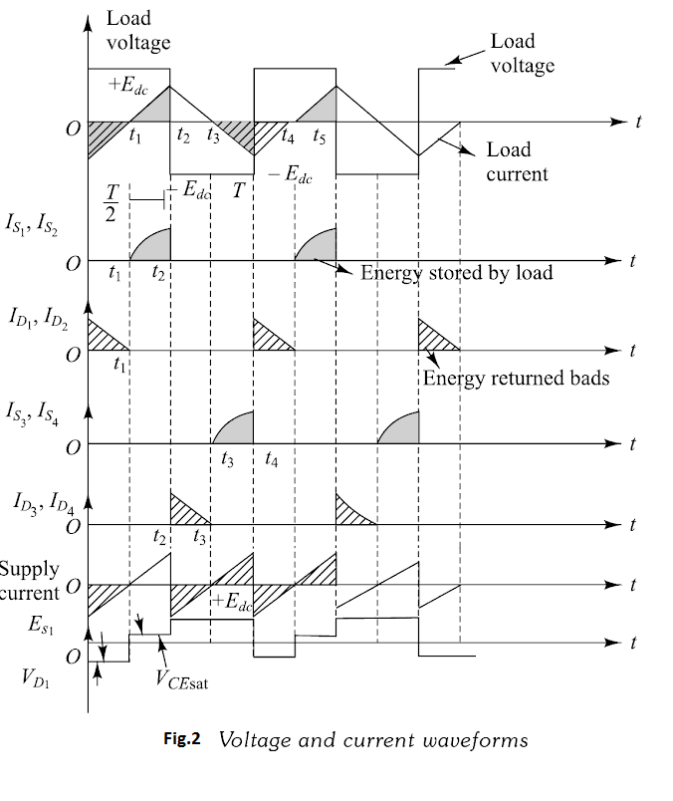

**Half Bridge Inverter Vs Full Bridge Inverter**

The difference between half-bridge inverter and full-bridge inverter is shown in the below table.

|  |  |  |
| --- | --- | --- |
| **S.NO** | **Half Bridge Inverter** | **Full Bridge Inverter** |
| 1 | The efficiency is high in half-bridge inverter | In full-bridge inverter also, the efficiency is high |
| 2 | In half-bridge inverter the output voltage waveforms are square, quasi square or PWM | In full-bridge inverter the output voltage  waveforms are square, quasi square or PWM |
| 3 | The peak voltage in the half-bridge inverter is half of the DC supply voltage | The peak voltage in the full-bridge inverter  is the same as the DC supply voltage |
| 4 | The half-bridge inverter contains two switches | The full-bridge inverter contains four switches |
| 5 | The output voltage is E0= EDC /2 | The output voltage is E0= EDC |
| 6 | The fundamental output voltage is E1= 0.45 EDC | The fundamental output voltage is E1= 0.9 EDC |
| 7 | This type of inverter generates bipolar voltages | This type of inverter generates monopolar voltages |

**Advantages**

The advantages of the single-phase half-bridge inverter are

* Circuit is simple
* Cost is low

**Disadvantages**

The disadvantages of the single-phase half-bridge inverter are

* The TUF (Transformer Utilization Factor) is low
* Efficiency is low

**180°** mode **Voltage Source Inverter**   
in Three phase inverter:

The voltage source inverter has stiff DC source voltage that is the DC voltage has limited or zero impedance at the inverter input terminals.

In this mode of conduction, every device is in conduction state for 180° where they are switched ON at 60° intervals. The terminals A, B and C are the output terminals of the bridge that are connected to the three-phase delta or star connection of the load

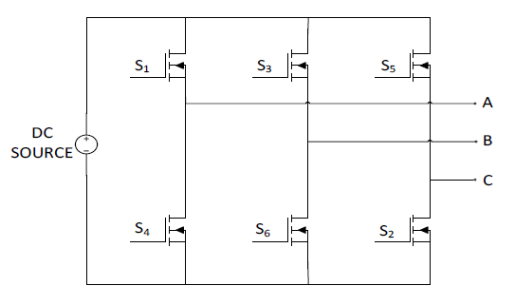Fig: Circuit diagram of three phase inverter

180 degree conduction mode:

|  |  |  |  |  |  |  |
| --- | --- | --- | --- | --- | --- | --- |
| Mode | S1 | S2 | S3 | S4 | S5 | S6 |
| 1st | ON | OFF | OFF | OFF | ON | ON |
| 2nd | ON | ON | OFF | OFF | OFF | ON |
| 3rd | ON | ON | ON | OFF | OFF | OFF |
| 4th | OFF | ON | ON | ON | OFF | OFF |
| 5th | OFF | OFF | ON | ON | ON | OFF |
| 6th | OFF | OFF | OFF | ON | ON | ON |

Table: Switching of 180 Degree conduction mode

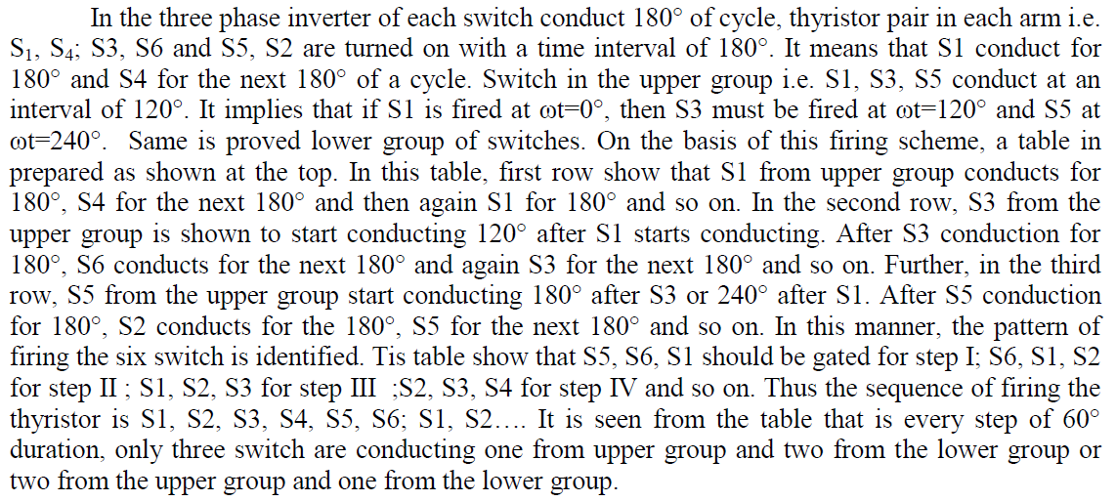

Wave form:

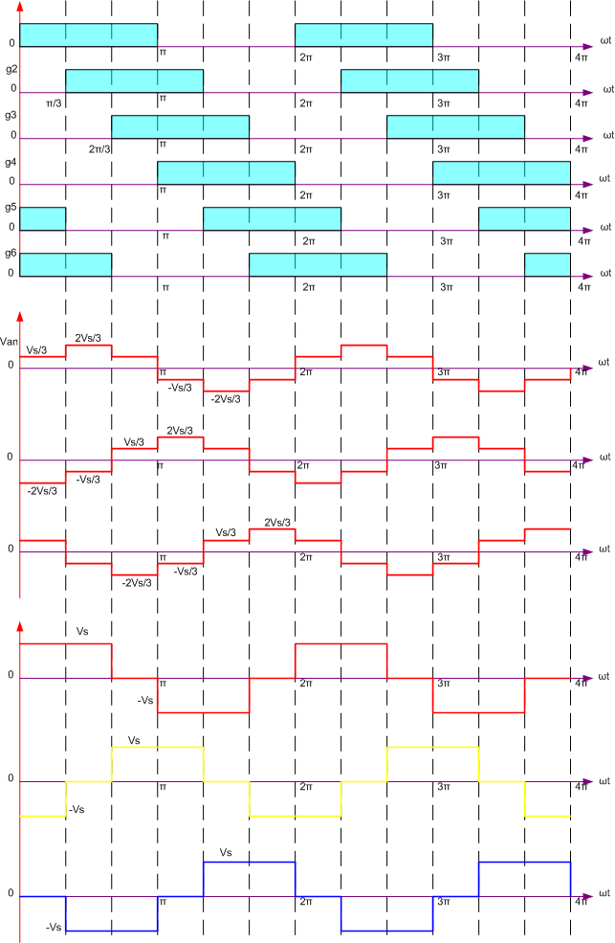

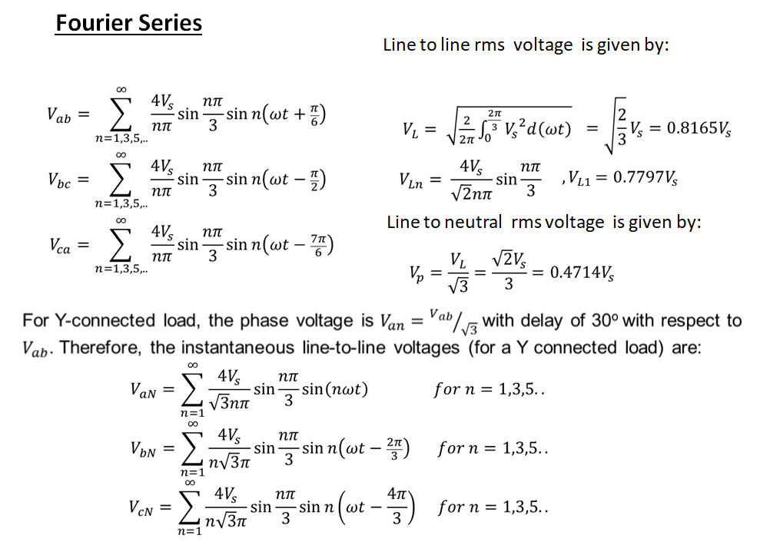

**THREE PHASE INVERTER 120o CONDUCTION**

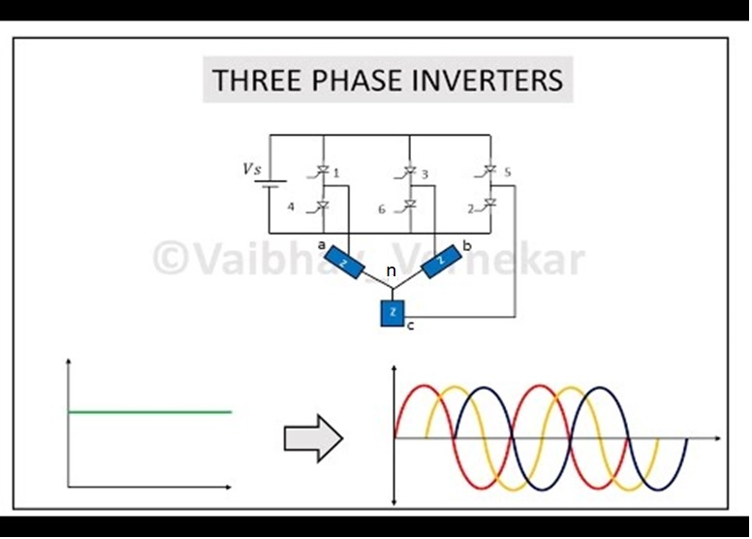

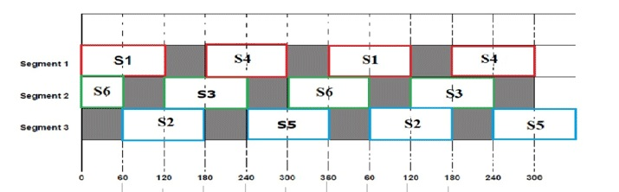

In this mode of conduction, each electronic device is in a conduction state for 120°. It is most suitable for a delta connection in a load because it results in a six-step type of waveform across any of its phases. Therefore, at any instant only two devices are conducting because each device conducts at only 120°.

In mode 1

The terminal A on the load is connected to the positive end while the terminal B is connected to the negative end of the source. The terminal C on the load is in a condition called floating state. Furthermore, the phase voltages are equal to the load voltage.

Similarly , in mode 2 , terminal A and C is connected and B is floating

In mode 3 , terminal B and C is connected and A is floating .

Mode 1

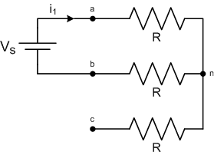

$$R_{eq}=R+R=2R$$

$$v_{an}= \frac{V_{s}}{2}$$

$${ v}_{bn}= \frac{{-V}_{s}}{2}$$

$$v_{cn}=0$$

Mode 2

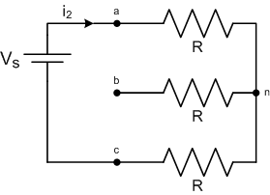

$$R_{eq}=R+R=2R$$

$${ v}_{an}= \frac{V_{s}}{2}$$

$${ v}_{cn}= \frac{{-V}_{s}}{2}$$

$$v_{bn}=0$$

Mode 3

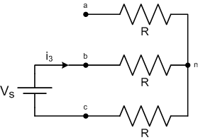

$$R_{eq}=R+R=2R$$

$$v_{bn}=\frac{V_{s}}{2}$$

$${ v}_{cn}=\frac{{-V}_{s}}{2}$$

$$v_{an}=0$$

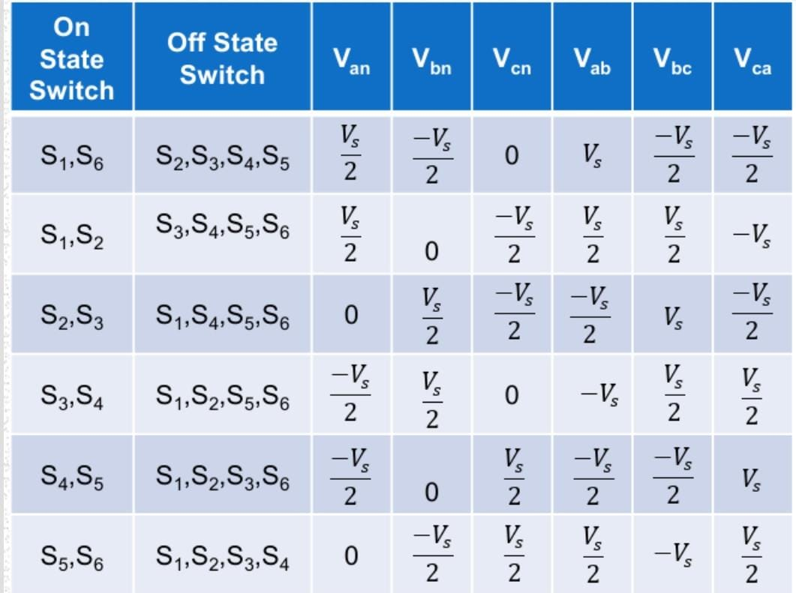

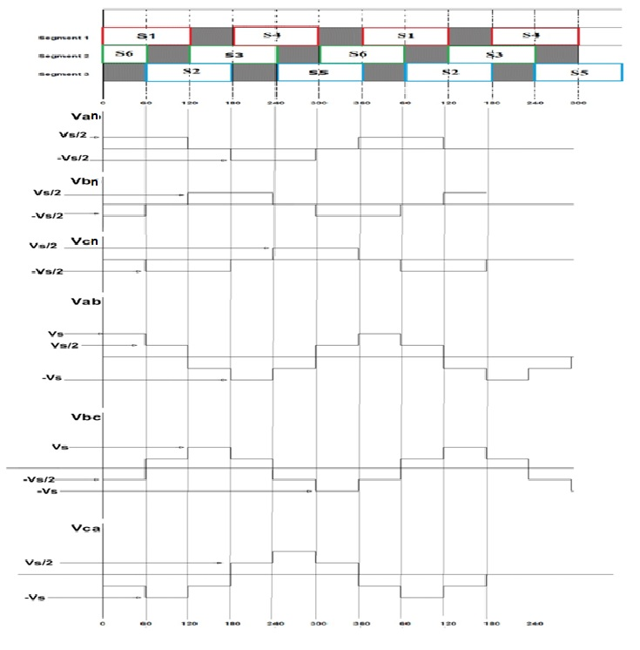

**Fourier Series**

**Line to neutral voltage**

${ V}_{an}=\sum_{n=6k±1}^{∞}{\frac{2V_{s}}{nπ}\sin{\frac{nπ}{3}\sin{n\left(ωt+\frac{π}{6}\right)}}}$ $for k=0,1,2,3..$

${ V}_{bn}=\sum_{n=6k±1}^{∞}{\frac{2V_{s}}{nπ}\sin{\frac{nπ}{3}\sin{n\left(ωt-\frac{π}{2}\right)}}}$ $for k=0,1,2,3..$

${ V}_{cn}=\sum_{n=6k±1}^{∞}{\frac{2V_{s}}{nπ}\sin{\frac{nπ}{3}\sin{n\left(ωt-\frac{7π}{6}\right)}}}$ $for k=0,1,2,3..$

* $V_{{an}_{1}}\left(peak\right)=\frac{√3V_{S}}{π}$, $V_{{an}_{1}}\left(rms\right)=\frac{√3V_{S}}{π√2}$

**Line to line voltage**

$$V_{ab}=\sum_{n=6k±1}^{∞}{\frac{3V_{s}}{nπ}}\sin{n\left(ωt+\frac{π}{3}\right) for k=0,1,2,3..}$$

$$V_{bc}=\sum_{n=6k±1}^{∞}{\frac{3V_{s}}{nπ}\sin{n\left(ωt-\frac{π}{3}\right) for k=0,1,2,3..}}$$

$$V_{ca}=\sum_{n=6k±1}^{∞}{\frac{3V_{s}}{nπ}\sin{n\left(ωt-π\right) for k=0,1,2,3..}}$$

* $V_{{ab}_{1}}\left(peak\right)=\frac{3V_{S}}{2π}$, $V_{{ab}_{1}}\left(rms\right)=\frac{3V_{S}}{π√2}$

3.

CONTROL

SYSTEM

***CONTROL SYSTEM***

control system are basically two type

1. Open loop control system.
2. closed loop control system

***Open loop control system:***

The control system in which no feedback is involved is called open loop control system.

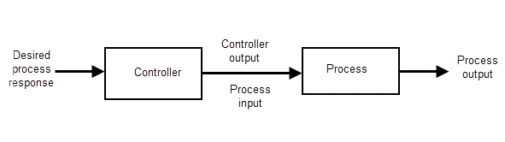

Open loop control system modifies output based on predetermined control values.

***Cosed loop control system:***

The control system in which feedback system is present is called closed loop control system.

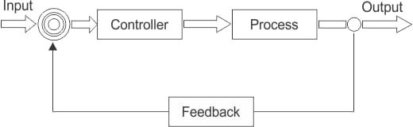

Closed loop control modifies output on measured value of control variable measured value compared to desired value and used to maintain desired value when disturbances occurs closed loop control uses feedback of output to input.

***Transfer function of open loop control system:***

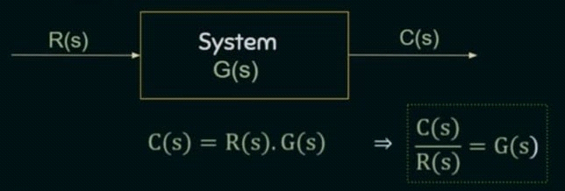

* G(s) is the transfer function of the closed loop control system.
* R(s) is lhe laplace of input signal.
* C(s) is the laplace of the output response.

***Transfer function of closed loop control system:***

There are two type of feedback in closed loop control system.

1. Positive feedback
2. Negative feedback

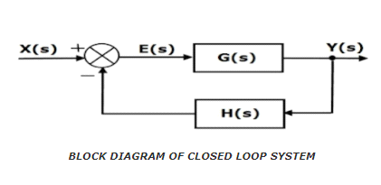

Above fig. shows the Block Diagram of Closed Loop Control System, where

E(s) = Actuating or Error Signal

X(s) = Reference Input Signal.

G(s) = Forward Path Transfer Function.

Y(s) = Output Signal.

H(s) = Feedback Transfer Function.

B(s) = Feedback Signal.

So, the transfer function of the closed loop system is Y(s)/X(s).

From the block diagram,

Y(s) = G(s).E(s) .........1

B(s) = H(s).Y(s) .........2

E(s) = X(s) + B(s) .........3a (For positive feedback)

= X(s) - B(s) ..........3b (For negative feedback)

FOR NEGATIVE FEEDBACK (using eq.3b)

Put the value of E(s) from eq.3b in eq.1

Y(s) = G(s).[X(s)-B(s)]

Y(s) = G(s).X(s) - G(s).B(s) .........4

Put the value of B(s) from eq.2 in eq.4

Y(s) = G(s).X(s) - G(s).H(s).Y(s)

Y(s) + G(s).H(s).Y(s) = G(s).X(s)

Y(s){1 + G(s).H(s)} = G(s).X(s)

Y(s)/X(s) = G(s) / {1 +G(s).H(s)} .........5

FOR POSITIVE FEEDBACK (using eq.3a)

For positive feedback system we will use eq.3a and repeat the all the same steps and we will get the transfer function as;

Y(s)/X(s) = G(s) / {1 - G(s).H(s)} .........6

FOR UNITY FEEDBACK

For unity feedback H(s) = 1, the eq.5 & eq.6 will become

Y(s)/X(s) = G(s)/{1 + G(s)} .......for negative unity feedback

Y(s)/X(s) = G(s)/{1 - G(s)} ........for postive unity feedback

***DIFFERENCE BETWEEN OPEN LOOP AND CLOSED LOOP TRANSFER FUNCTION:***

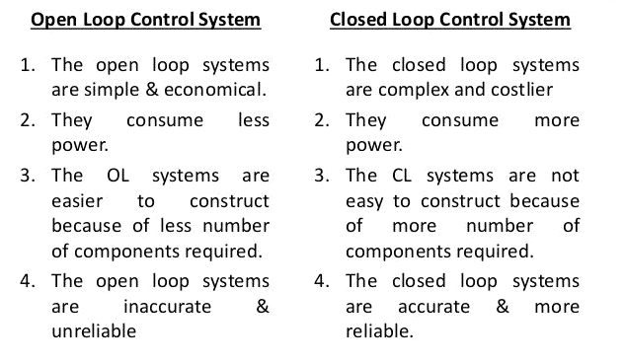

Steady State Error

The deviation of the output of control system from desired response during steady state is known as **steady state error**.

It is represented as ess. We can find steady state error using the final value theorem as follows.

*ess = limt→∞ e(t) = lims→0 s.E(s)ess= limt→∞e(t) = lims→0s.E(s)*

Where,

E(s) is the Laplace transform of the error signal, e(t)e(t)

Let us discuss how to find steady state errors for unity feedback and non-unity feedback control systems one by one.

**Steady State Errors for Unity Feedback Systems:**

Consider the following block diagram of closed loop control system, which is having unity negative feedback.

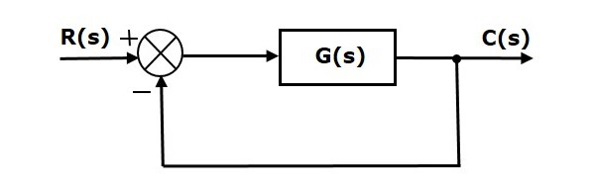

Where,

* R(s) is the Laplace transform of the reference Input signal r(t)r(t)
* C(s) is the Laplace transform of the output signal c(t)c(t)

We know the transfer function of the unity negative feedback closed loop control system as

C(s)R(s)=G(s)1+G(s)C(s)R(s)=G(s)1+G(s)

⇒C(s)=R(s)G(s)1+G(s)⇒C(s)=R(s)G(s)1+G(s)

The output of the summing point is -

E(s)=R(s)−C(s)E(s)=R(s)−C(s)

Substitute C(s)C(s) value in the above equation.

E(s)=R(s)−R(s)G(s)1+G(s)E(s)=R(s)−R(s)G(s)1+G(s)

⇒E(s)=R(s)+R(s)G(s)−R(s)G(s)1+G(s)⇒E(s)=R(s)+R(s)G(s)−R(s)G(s)1+G(s)

⇒E(s)=R(s)1+G(s)⇒E(s)=R(s)1+G(s)

Substitute E(s)E(s) value in the steady state error formula

ess=lims→0sR(s)1+G(s)ess=lims→0sR(s)1+G(s)

The following table shows the steady state errors and the error constants for standard input signals like unit step, unit ramp & unit parabolic signals.

|  |  |  |
| --- | --- | --- |
| **Input signal** | **Steady state error (**ess) | **Error constant** |
| unit step signal | 1/(1+kp) | Kp=lims→0G(s) |
| unit ramp signal | 1/Kv | $$Kv=lims→0sG(s)$$ |
| unit parabolic signal | 1/Ka | Ka=lims→0s2G(s) |

Where, Kp, Kv and Ka are position error constant, velocity error constant and acceleration error constant respectively.

**Note** − If any of the above input signals has the amplitude other than unity, then multiply corresponding steady state error with that amplitude.

**Note** − We can’t define the steady state error for the unit impulse signal because, it exists only at origin. So, we can’t compare the impulse response with the unit impulse input as **t** denotes infinity.

Example

Let us find the steady state error for an input signal r(t)=(5+2t+t22)u(t)r(t)=(5+2t+t22)u(t) of unity negative feedback control system with G(s)=5(s+4)s2(s+1)(s+20)G(s)=5(s+4)s2(s+1)(s+20)

The given input signal is a combination of three signals step, ramp and parabolic. The following table shows the error constants and steady state error values for these three signals.

|  |  |  |
| --- | --- | --- |
| **Input signal** | **Error constant** | **Steady state error** |
| r1(t)=5u(t)r1(t)=5u(t) | Kp = lims→0G(s) = ∞ | ess1 = 51+kp=0 |
| r2(t)=2tu(t)r2(t)=2tu(t) | Kv = lims→0 sG(s)=∞ | ess2 = 2Kv=0 |
| r3(t)=t22.u(t)r3(t)=t22u(t) | Ka=lims→0 s2.G(s)=1 | ess3 = 1ka=1 |

We will get the overall steady state error, by adding the above three steady state errors.

ess = ess1+ess2+ess3.ess

ess = ess1+ess2+ess3

⇒ ess=0+0+1=1

⇒ ess= 0+0+1=1

Therefore, we got the steady state error ess as **1** for this example.

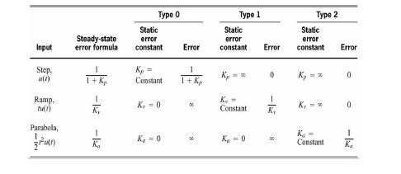

**Steady State Errors for Non-Unity Feedback Systems:**

Consider the following block diagram of closed loop control system, which is having nonunary negative feedback.

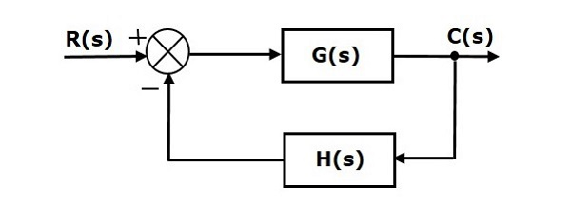

We can find the steady state errors only for the unity feedback systems. So, we have to convert the non-unity feedback system into unity feedback system. For this, include one unity positive feedback path and one unity negative feedback path in the above block diagram. The new block diagram looks like as shown below.

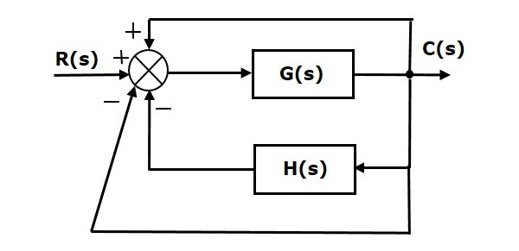

Simplify the above block diagram by keeping the unity negative feedback as it is. The following is the simplified block diagram.

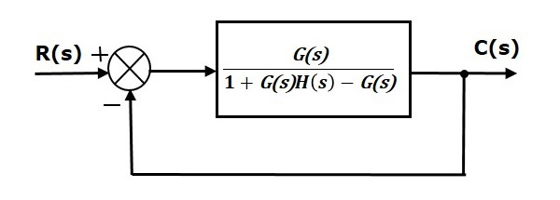

This block diagram resembles the block diagram of the unity negative feedback closed loop control system. Here, the single block is having the transfer function G(s)1+G(s)H(s)−G(s)G(s).1+G(s)H(s)−G(s) instead of G(s)G(s). You can now calculate the steady state errors by using steady state error formula given for the unity negative feedback systems.

**Note** − It is meaningless to find the steady state errors for unstable closed loop systems. So, we have to calculate the steady state errors only for closed loop stable systems. This means we need to check whether the control system is stable or not before finding the steady state errors. In the next chapter, we will discuss the concepts-related stability.

 Categories

Top of Form

|  |  |
| --- | --- |
|  |  |

Bottom of Form

Control Systems - Controllers

The various types of controllers are used to improve the performance of control systems. In this chapter, we will discuss the basic controllers such as the proportional, the derivative and the integral controllers.

Proportional Controller

The proportional controller produces an output, which is proportional to error signal.

u(t) ∝ e(t)

⇒u(t)= KP .e(t)

Apply Laplace transform on both the sides -

U(s)=KP. E(s)

U(s)/E(s)=KP

Therefore, the transfer function of the proportional controller is KP.

* Where,

U(s) is the Laplace transform of the actuating signal u(t)

E(s) is the Laplace transform of the error signal e(t)

KP is the proportionality constant.

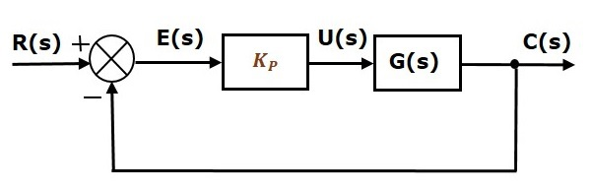

The proportional controller is used to change the transient response as per the requirement.

Derivative Controller

The derivative controller produces an output, which is derivative of the error signal.

u(t) α de(t)/d(t)

u(t)=KD .de(t)/dt

Apply Laplace transform on both sides.

U(s)=KD .SE(S)

U(s)/E(s)=KD .S

Therefore, the transfer function of the derivative controller is KD.S.

Where, KD is the derivative constant.

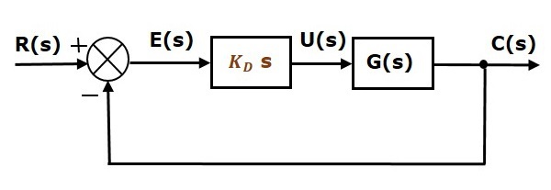

The derivative controller is used to make the unstable control system into a stable one.

Integral Controller

The integral controller produces an output, which is integral of the error signal.

u(t) α ∫e(t)d(t)

u(t)=KI. ∫e(t)dt

Apply Laplace transform on both the sides -

U(s)=KI. E(s)/s

U(s)/E(s)=KI/s.

Therefore, the transfer function of the integral controller is KI/s.

Where, KI is the integral constant.

.

.

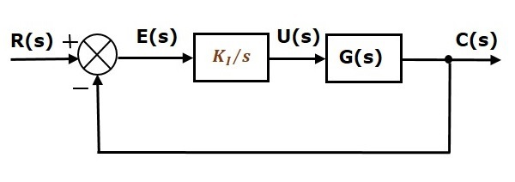

The integral controller is used to decrease the steady state error.

Let us now discuss about the combination of basic controllers.

Proportional Derivative (PD) Controller

The proportional derivative controller produces an output, which is the combination of the outputs of proportional and derivative controllers.

u(t) α[ e(t) +de(t)/d(t)]

u(t)=KP .e(t)+ KD .de(t)/dt.

Apply Laplace transform on both sides -

U(s)= (KP +KD. S) .E(s)

U(s)/E(s)=KP +KD .S

Therefore, the transfer function of the proportional derivative controller is KP+KD.S

.

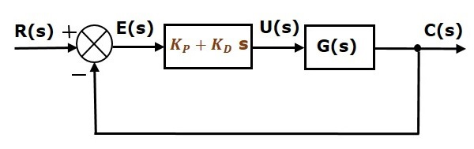

The proportional derivative controller is used to improve the stability of control system without affecting the steady state error.

Proportional Integral (PI) Controller

The proportional integral controller produces an output, which is the combination of outputs of the proportional and integral controllers.

* PI controller can be described that It is produce an output which is the combination of outputs of proportional and integral controller .
* PI control is a form of feedback control. It provides a faster response time than I-only control due to the addition of the proportional action. PI control stops the system from fluctuating, and it is also able to return the system to its set point. Although the response time for PI-control is faster than I-only control, it is still up to 50% slower than P-only control. Therefore, in order to increase response time, PI control is often combined with D-only control.
* PI controller is mainly used to eliminate the steady state error resulting from P controller. However, in terms of the speed of the response and overall stability of the system, it has a negative impact. This controller is mostly used in areas where speed of the system is not an issue. Since P-I controller has no ability to predict the future errors of the system it cannot decrease the rise time and eliminate the oscillations. If applied, any amount of I guarantees set point overshoot.

, u(t) $∝$ e(t) + $\int{e(t)}$

u(t) = ${ K}_{p}$ e(t) + ${ K}_{i}\int{e(t)}$

Let , L.T on B.S

U(S) = ${ K}_{p}$ E(s) + ${ K}_{i}$ $\frac{E(S)}{S}$

U(S) = E(S)( ${ K}_{p}$ + $\frac{K_{i}}{S}$)

K(s) = $\frac{U(s)}{E(s)}$ = ${ K}_{p}$ + $\frac{K_{i}}{S}$ = $\frac{K_{p }(s+{K_{i}}/{K_{p}})}{S}$

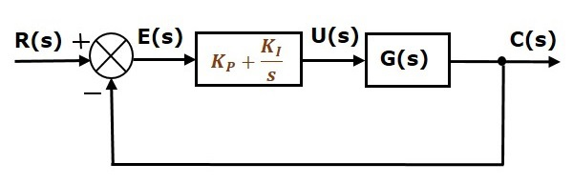

The PI controller thus adds a pole at the origin (an integrator) and a finite zero to the feedback loop. The presence of the integrator in the loop forces the error to a constant input to go to zero in steady-state; hence PI controller is commonly used in designing servomechanisms.

.

Proportional Integral Derivative (PID) Controller

* PID controller can be described that it produces an output , which is the combination of the output of proportional integral and derivative controller .
* PID controller has the optimum control dynamics including zero steady state error, fast response (short rise time), no oscillations and higher stability. The necessity of using a derivative gain component in addition to the PI controller is to eliminate the overshoot and the oscillations occurring in the output response of the system. One of the main advantages of the PID controller is that it can be used with higher order processes including more than single energy storage.
* A PID controller  is an instrument used in industrial control applications to regulate temperature, flow, pressure, speed and other process variables. PID (proportional integral derivative) controllers use a control loop feedback mechanism to control process variables and are the most accurate and stable controller.

The proportional integral derivative controller produces an output, which is the combination of the outputs of proportional, integral and derivative controllers.

Now, u(t) $∝$ e(t) + $\int{e(t)}$ + $\frac{ⅆ}{ⅆt}$ e(t)

u(t) = ${ K}_{p}$ e(t) + ${ K}_{i}\int{e(t)}+K_{d}$ $\frac{ⅆ}{ⅆt}$ e(t)

Let , L.T on B.S

U(S) = ${ K}_{p}$ E(s) + ${ K}_{i}$ $\frac{E(S)}{S}+K_{d}$ SE(S)

U(S) = E(S)( ${ K}_{p}$ + $\frac{K_{i}}{S}$ + $K_{d}$ S)

K(s) = $\frac{U(s)}{E(s)}$ = ${ K}_{p}$ + $\frac{K_{i}}{S}$ + $K_{d}S$

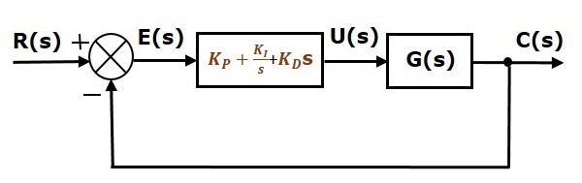

The controller gains for the three basic modes of control are given as {$K_{p},K_{d}{,K}_{i}$}Of these, the proportional term serves as a static controller, the derivative term helps speed up the system response, and the integral term helps reduce the steady-state error

4.

ELECTRIC

DRIVES

Pole Changing Method :

pole Changing Method is one of the main methods of the speed control of an induction motor. This method of controlling the speed by pole changing is used mainly for cage motor only because the cage rotor automatically develops a number of poles, which is equal to the poles of the stator winding. The number of stator poles can be changed by the following three methods. They are known as multiple stator windings, method of consequent poles and pole amplitude modulation (PAM).

The detail explanation of each pole changing method is given below.

Multiple Stator Winding:

In the multiple stator winding method, two windings are provided on the stator which are wound on the two different numbers of pole. One winding is energized one at a time. Let us consider that the motor has two windings for 6 and 4 poles. For the frequency of 50 hertz, the synchronous speeds will be 1000 and 1500 revolutions per minute respectively. This method of speed control is less efficient and more costly.

Method of Consequent Pole:

In the method of consequent poles, a single stator winding is divided into few coil groups. The terminals of all these groups are brought out. By simply changing the coil connections, the number of poles can be changed. In practice, the stator windings are divided only in two coil groups. The number of poles can be changed in the ratio of 2:1. The figure below shows the single phase of a stator winding which consist of 4 coils. The coils are divided into two groups named as a-b and c-d

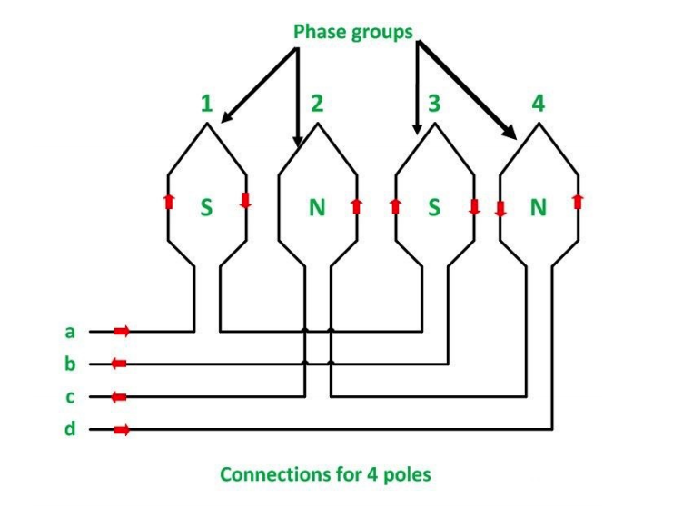

Group a-b consists of an odd number of coils that is (1, 3) whereas group c-d consists of an even number of coils (2,4). The two coils are connected in series. The terminals a, b, c, d are taken out as shown in the above figure. The coils are carrying current in the given directions by connecting coil groups either in series or in parallel as shown in the figure below

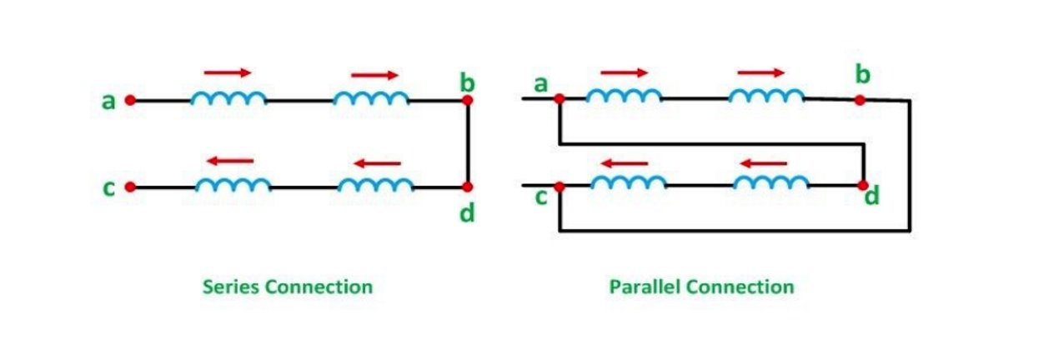

There are total four poles which are giving a speed of 1500 rpm for a 50-hertz system. If the current through the coils of group a-b is reversed as shown in the figure below. All the coils will produce north (N) poles.

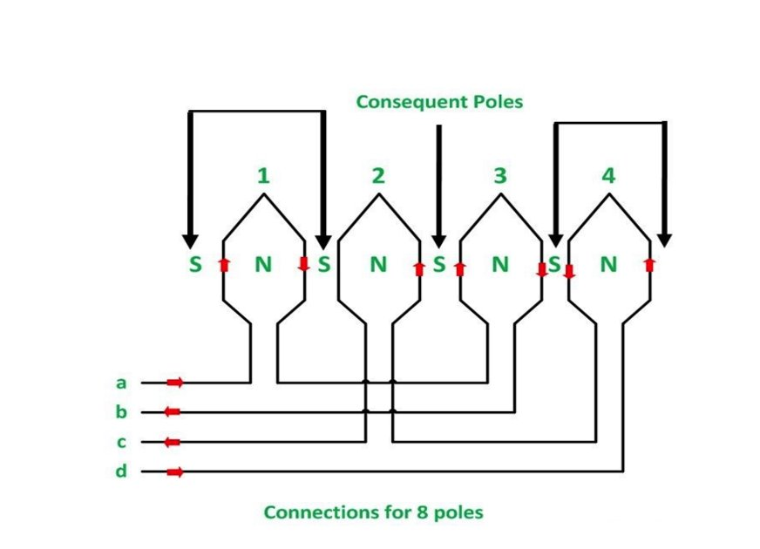

The flux of the poles group should be passed through the given space between the pole group to complete the magnetic path. Thus, a magnetic pole of opposite polarity (S pole) is induced. These induced poles are known as Consequent Poles. Thus, the machine has twice as many poles as before (i.e., 8 poles), and the synchronous speed becomes half of the previous speed (i.e., 750 rpm). The above principle can be extended to all the three phases of an induction motor. By choosing a combination of series and parallel connections between the coil groups of each phase. Also, the star or delta connections between the phase speed change can be obtained with constant torque and constant power operation or variable torque operation.

Pole Amplitude Modulation:

In this method of speed control of three phase induction motor the original sinusoidal mmf wave is modulated by another sinusoidal mmf wave having the different number of poles. Let f1(θ) be the original mmf wave of induction motor whose speed is to be controlled.

f2(θ) be the modulation mmf wave. P1 be the number of poles of induction motor whose speed is to be controlled. P2 be the number of poles of modulation wave.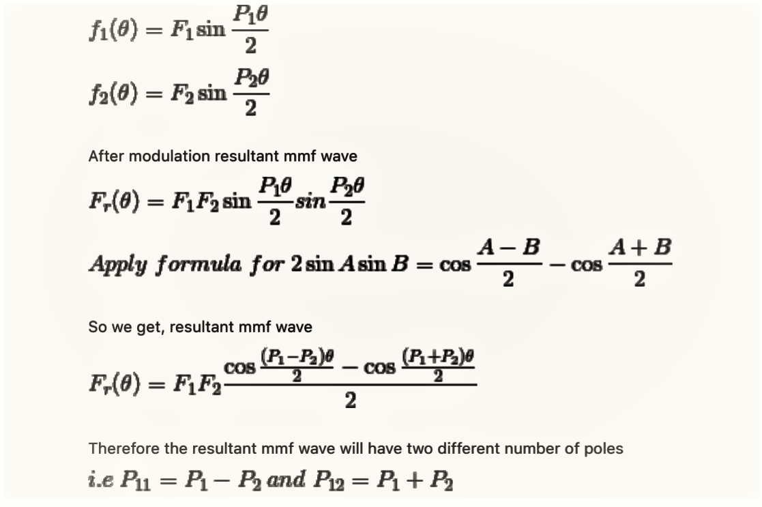

Therefore by changing the number of poles we can easily change the speed of three phase induction motor.

**Pole Amplitude Modulation Induction Motor:**

Pole changing method as already discussed allows a change of speed by a factor 2. In some applications, speed change is required only by a small amount, e.g. some fan and pump drives require speed reduction to reduce power output at the most to half of rated. Since, torque is proportional to speed squared in a fan drive, power is proportional to (speed)3. Half of rated power is obtained when speed is reduced approximately by 20%. Such a small change in speed is possible by Pole Amplitude Modulation Induction Motor.

The mmf distribution in air-gap owing to stator winding of a three-phase induction motor may be written generally as

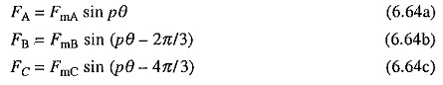

where θ is the mechanical angle.

In an ordinary induction motor, the amplitudes of mmfs FmA, FmB and FmC, are constant and equal. In method under discussion, amplitudes are varied (or modulated) according to the rule:

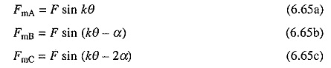

theoretically k and α may have any values.

Substitution from Eq. (6.65) into (6.64) yields

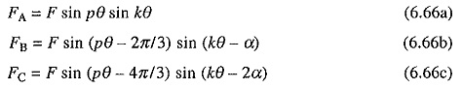

which may be written as

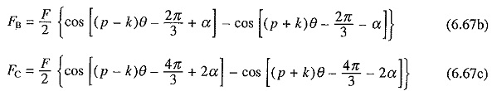

Thus, Pole Amplitude Modulation Induction Motor of mmfs in a three-phase machine having p poles, produces two sets of three-phase mmfs with (p – k) and (p + k) poles. Since, two sets of poles will produce torques in opposite directions, one of them must be suppressed. This can be achieved by choosing the value of α either 2π/3 or –2π/3. From Eq. (6.67) it is evident that modified pole numbers will be (p + k) in former and (p – k) in the latter, as other pole system produces co-phasal mmfs which do not produce any average torque.

Usually value of k, which is known as **modulation cycle**, is made unity. Even then it is very difficult to implement the modulation law of Eqs. (6.66) because of its sinusoidal nature. It can, however, be simplified as

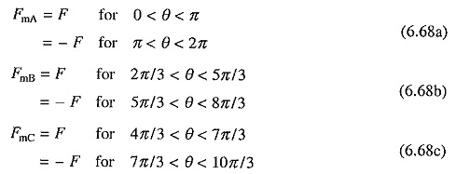

Modulating function for phase A is shown in Fig. 6.29(a). Sinusoidal law of modulation thus has been approximated by a rectangular ac wave. It means that for change in pole number current through the later half of coils in each phase is reversed. This law is known as **Coil Inversion**. Fig. 6.30 shows implementation of this law for a 8-pole stator. With current direction shown in Fig. 6.30(a), machine operates with 8-poles. Reversal of coil group c-d changes the number of poles to 10 as shown in Fig. 6.30(b). Here also the required direction of currents through coils can be obtained by connecting coil groups a-b and c-d either in series or parallel. By proper choice of series and parallel connections on one hand and delta and star on the other hand, constant torque, constant power and variable torque operations can be obtained.

Another simple law of Pole Amplitude Modulation Induction Motor, known as coil inversion and omission, is shown in Fig. 6.29(b) for phase A. This will however require that the connections are brought out for three coil groups for each phase. By drawing a figure similar to Fig. 6.30, it can be shown that the Pole Amplitude Modulation Induction Motor of a 8-pole machine gives 6-poles.

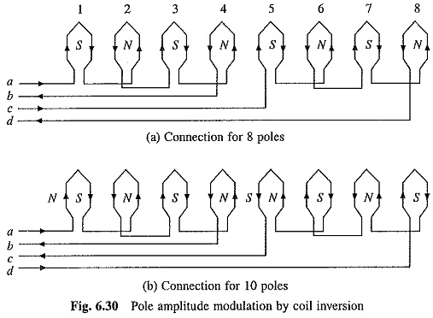

As pole-systems are not alternating along the periphery, these motors in modified connection suffer from harmonic currents and voltages, and have lower power factor and efficiency than pole changing motors described in the earlier section. They find applications in fan, blower and pump [drives](http://www.allaboutcircuits.com/).

**Stator Voltage Control of an Induction Motor:**

**Stator Voltage Control** is a method used to control the speed of an **Induction Motor.** The speed of a three-phase induction motor can be varied by varying the supply voltage. As we already know that the torque developed is proportional to the square of the supply voltage and the slip at the maximum torque is independent of the supply voltage. The variation in the supply voltage does not alter the synchronous speed of the motor.

The **Torque-Speed Characteristics** of the three-phase induction motors for varying supply voltage and also for fan load are shown below:

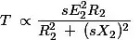

[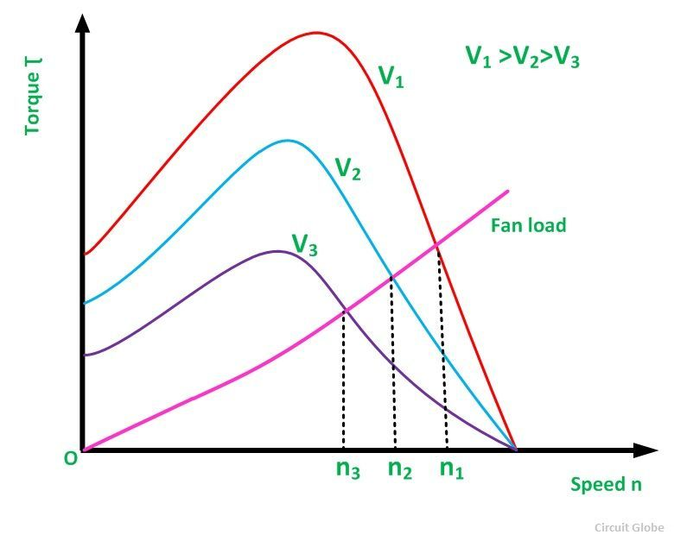](https://circuitglobe.com/wp-content/uploads/2016/02/stator-voltage-control-of-an-induction-motor-fig-1.jpg)

By varying the **supplying voltage**, the speed can be controlled. The voltage is varied until the torque required by the load is developed, at the desired speed. The torque developed is proportional to the square of the supply voltage and the current is proportional to the voltage.

Hence, to reduce the speed for the same value of the same current, the value of the voltage is reduced and as a result, the torque developed by the motor is reduced. This stator voltage control method is suitable for applications where the load torque decreases with the speed. **For example-** In the fan load.

This method gives a**speed control** only below the normal rated speed as the operation of the voltages if higher than the rated voltage is not admissible. This method is suitable where the intermittent operation of the drive is required and also for the fan and pump drives. As in fan and pump the load torque varies as the square of the speed. These types of drives required low torque at lower speeds. This condition can be obtained by applying a lower voltage without exceeding the motor current.

The variable voltage for speed control of small size motors mainly for single-phase can be obtained by the following methods given below:

* By connecting an external resistance in the stator circuit of the motor.
* By using an Auto-transformer.
* By using a Thyristor voltage controller.
* By using a Triac Controller.

Nowadays the **Thyristor voltage controller** method is preferred for varying the voltage. For a single-phase supply, two thyristors are connected back to back as shown in the figure below:

[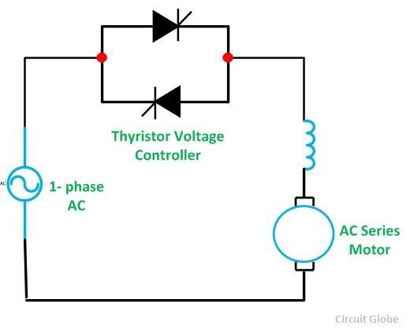](https://circuitglobe.com/wp-content/uploads/2016/02/stator-voltage-control-of-an-induction-motor-fig-2.jpg)

The domestic fan motors, which are single-phase are controlled by a single-phase **Triac Voltage Controller** as shown in the figure below:

[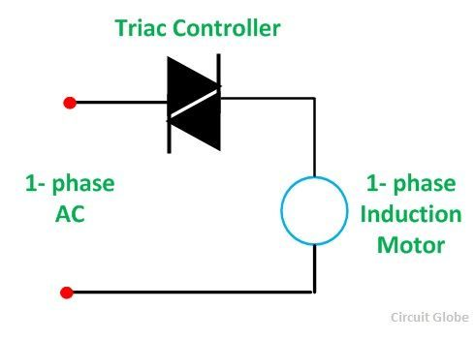](https://circuitglobe.com/wp-content/uploads/2016/02/stator-voltage-control-of-an-induction-motor-fig-3.jpg)

**Speed control** is obtained by varying the firing angle of the **Triac**. These controllers are known as **Solid State fan regulators**. As the solid-state regulators are more compact and efficient as compared to the conventional variable regulator. Thus, they are preferred over the normal regulator.

In the case of a three-phase induction motor, three pairs of thyristors are required which are connected back to back. Each pair consists of two

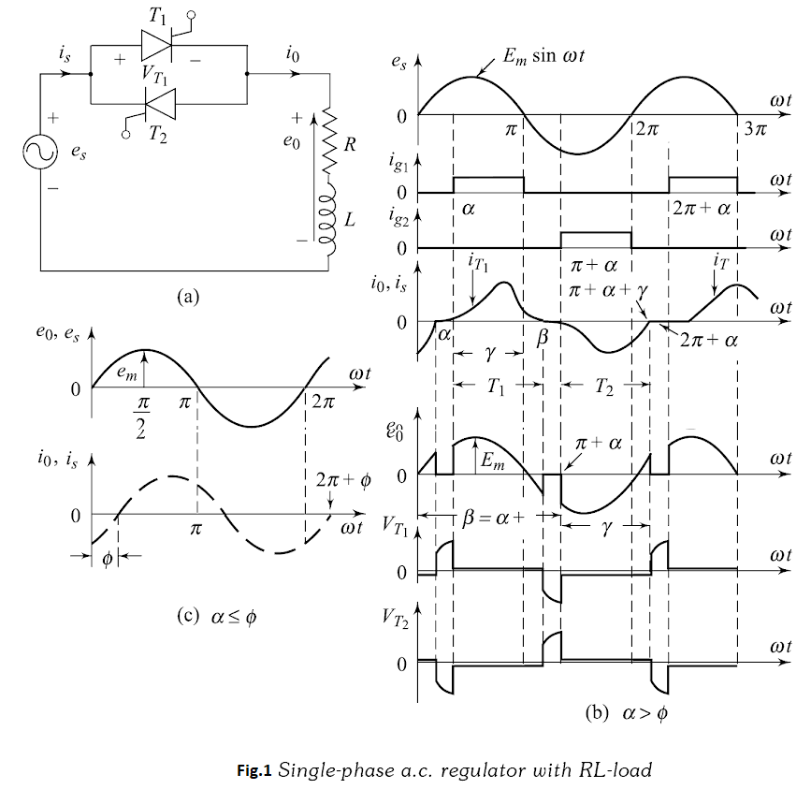

thyristors. The diagram below shows the**Stator Voltage Control** of the three-phase induction motors by **Thyristor Voltage Controller.**

[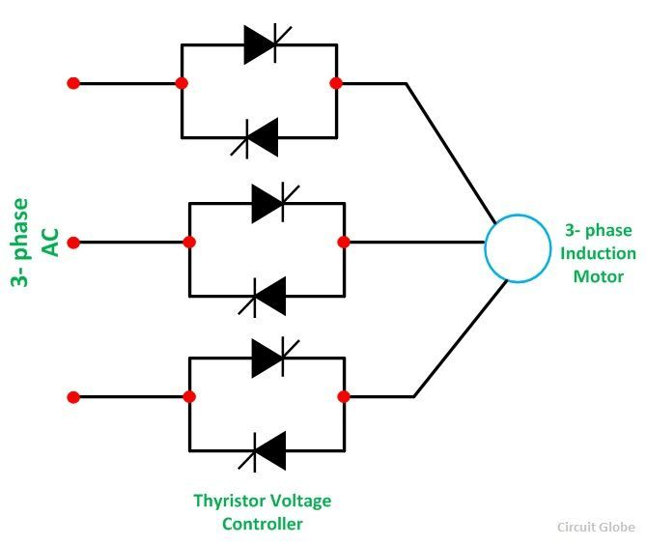](https://circuitglobe.com/wp-content/uploads/2016/02/stator-voltage-control-of-an-induction-motor-fig-4.jpg)

Each pair of the thyristor controls the voltage of the phase to which it is connected. Speed control is obtained by varying the conduction period of the Thyristor. For lower power ratings, the back-to-back thyristor pairs connected in each phase are replaced by the Traic.

**V/F CONTROL OF THREE PHASE INDUCTION MOTOR**

V/F is abbreviated from voltage/frequency. V/F control is an induction motor control method which ensures the output voltage proportional with the frequency, so it maintains a constant motor flux, preventing weak magnetic and magnetic saturation phenomenon from happening.

V/F control principle is to produce a circuit called voltage-controller oscillator with oscillator frequency. It is a voltage-dependent capacitance, when subjected to a change in voltage, its capacity will change, and then the change in capacity will cause changes in the oscillation frequency, resulting in [variable frequency](https://www.veichi.org/product/electric-drive/). This controlled frequency is used to control the frequency of the output voltage, in order to achieve speed changes of the controlled electric motors.

Applications of V/F Control

Asynchronous electric motor torque is a result of the interaction of flux and rotor flux. At a rated frequency, if voltage is set to a certain value and only reduce the frequency, then there will be large magnetic flux and magnetic circuit saturation (severely, it will burn motor). Therefore, the frequency and voltage must be changed proportionally. When changing the frequency, we should control the output voltage of [AC drive](https://www.veichi.org/product/electric-drive/), in order to keep constant flux and avoid weak magnetic and magnetic saturation phenomenon. This control method is commonly applied for fans and pumps.

**Circuit diagram**

[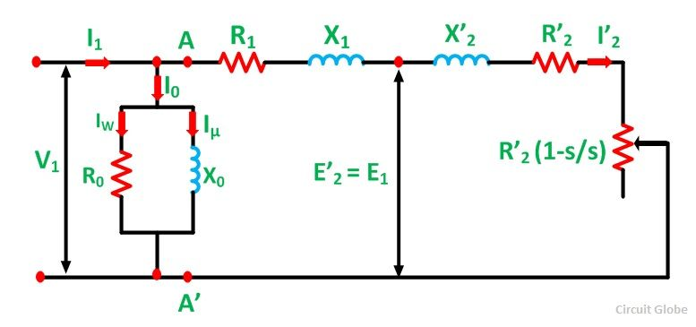](https://circuitglobe.com/wp-content/uploads/2016/02/EQUIVALENT-CIRCUIT-OF-AN-INDUCTION-MOTOR-FIG-3.jpg)

Case 1

$$v=v_{rated}=constant , f↑$$

$$N_{s}=\frac{120f↑}{p}$$

$$∅∝\frac{v}{f↑}$$

$T_{max}=\frac{3}{w_{s}↑}*\frac{v_{1}^{2}}{2x_{2}^{'}↑}$ $[x_{2}^{'}∝f$, $[w_{s}∝f]$

$$T_{start}=\frac{3}{w_{s}}*\frac{v_{1}^{2}r_{2}^{'}}{sx_{2}^{'^{2}}}$$

$${↓T}_{start}∝\frac{1}{f^{3}↑}$$

$$↓slip s_{MT}=\frac{r_{2}^{'}}{x_{2}^{'}}∝\frac{1}{f↑}$$

Here $:f↑, N_{s}$, But $:s_{MT}↓, T_{start}↓, T_{max}↓$

Case 2

$$∅=constant → \frac{v}{f}=constant$$

$$∅=\frac{v↓}{f↓}$$

$${↓N}_{s}=\frac{120f↓}{p}$$

$T_{max}=\frac{3}{w_{s}⬇}*\frac{v_{1}^{2}}{2x_{2}^{'}⬇}$ $[x_{2}^{'}∝f$, $[w_{s}∝f]$

$$T_{max}∝\frac{3v_{1}^{2}}{2f^{2}}=\frac{3}{2}{\left(\frac{v_{1}}{f}\right)}^{2}$$

$$∴T_{max}=constant, as \frac{v_{1}}{f}=constant$$

$$T_{start}=\frac{3}{w_{s}}*\frac{v_{1}^{2}r_{2}^{'}}{sx_{2}^{'^{2}}}$$

$$∴ {↑T}_{start}∝\frac{1}{f↓}$$

$$↑slip s_{MT}=\frac{r_{2}^{'}}{x_{2}^{'}}∝\frac{1}{f↓}$$

$$here, T_{max}=constant, T_{start}↑, slip s_{MT}↑$$

**TORQUE SLIP CHARACTERISTIC CURVE**

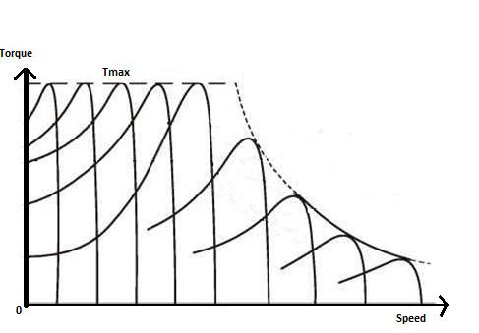

TORQUE SPEED CHARACTERISTICS CURVE

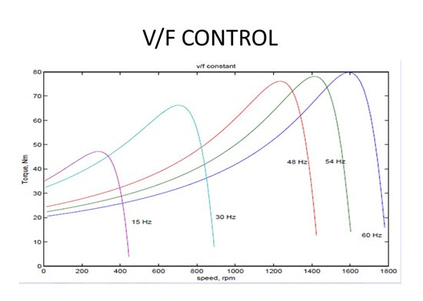

**Advantages of V/F Control:**

**1.High starting torque at low speed.**

**2.Vary speed over a wide range but keeping torque constant by varying frequency and speed in same proportion.**

**Disadvantages of V/F Control:**

**1. The only major disadvantage of V/f control is cost of inverter which has to perform the functions of rectification of existing AC into DC, then converting DC into three phase AC with provision of voltage and frequency variation.**

**2. Disadvantage of using v/f control is that you cannot go above synchronous speed, because you can't increase voltage above motor's rated voltage.**

**ROTOR RESISTANCE CONTROL FOR SPEED CONTROL OF 3**ϕ **IM** **:-**

Speed-torque curves for rotor resistance control are given in **Fig.1**

While maximum torque is independent of rotor resistance, speed at which the

maximum torque is produced changes with rotor resistance. For the same torque, speed falls with an increase in rotor resistance. Advantage of rotor resistance control is that motor torque capability remains unaltered even at low speeds. Only other method which has this advantage is variable frequency control. However, cost of rotor resistance control is very low compared to variable frequency control. Because of low cot ant high torque capability at low speed, rotor resistance control is employed in cranes, Ward Leonard Ilgener Drives, and other intermittent load applications. Major disadvantage is low efficiency due to additional losses in resistor connected in the rotor circuit. As the losses mainly take place in the external resistor thy do not-heat the motor.

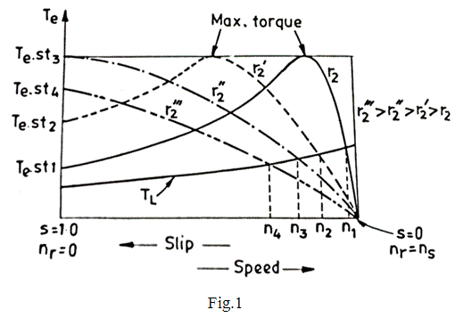

1. **Conventional Methods -**

Anumber of methods are used for obtaining variable resistance. In drum controllers,

resistance is varied by using rotary switches and a resistance divide in few steps. Variable resistance can also be obtained by using contactors and resistors in series. High power applications use a slip-regulator, which consists of three electrodes submerged in an electrolyte, consisting of saline water. Resistance is varied by changing the distance between electrode. When the power is high, electrodes are driven by a small motor. Advantage of this method is that resistance can be changed steplessly.

1. **Static Rotor Resistance Control -**

Rotor resistance can also be varied steplessly using circuit of **Fig. 2 -(6.5)**.

The ac output voltage of rotor is rectified by a diode bridge and fed to a parallel

combination of a fixed resistance $R$ and a semiconductor switch realised by a transistor $T_{r}$ (Fig. 2). Effective value of resistance across terminals **A** and **B**, $R_{AB}$, is varied by varying duty ratio of transistor $T_{r}$, which in turn varies rotor circuit resistance. Inductor $L_{d}$ is added to reduce ripple and discontinuity in the dc link current $I_{d}$. Rotor current waveform will be as shown in **Fig. 2 (b)**.

When the ripple is neglected. This rms rotor current will be

$I_{r}=\sqrt{\frac{2}{3}}{ I}_{d}$**------ (**1**)**

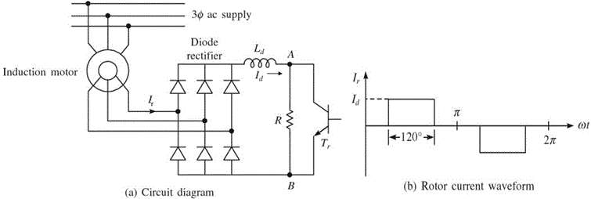

**Fig. 2** Rotor resistance control employing semiconductor converters

Resistance between terminal **A** & **B** will be zero when transistor is on and it will be **R** when it is off. Therefore, average value of resistance between the terminals is given by

$$R_{AB}=\left(1-δ\right)R$$

where $δ$ is the duty ratio of the transistor and givenPower consumed by $R_{AB}$ is

$P_{AB}=I_{d}^{2}R_{AB}= I_{d}^{2}R(1-δ)$**----- (**2**)**

From **Eqs. (6.88)** and **(6.89),** power consumed by $R_{AB}$ per phase is

Power consumed per phase $\frac{P_{AB}}{3}$**= $0.5R\left(1-δ\right)I_{r}^{2}$------ (**3**)**

Equation **(**3**)** suggests that rotor circuit resistance per phase is increased by $0.5R(1-δ)$. Thus, total rotor circuit resistance per phase will now be

$$R_{rT}=R_{r}+0.5R(1-δ)$$

$R_{rT}$ can be varied from $R_{r}$ to $(R_{r}+0.5R$**)** as $δ$ is changed from **1** to **0**.

A closed-loop speed control scheme with inner current control loop is shown in **Fig.6.52**

Rotor current $I_{r}$ and therefore, $I_{d}$ has a constant value at the maximum torque point, both during motoring and plugging. If the current limiter is made to saturate at this current, the drive will accelerate and decelerate at the maximum torque, given very fast transient response. For plugging to occur, arrangement will have to be made for reversal of phase sequence.

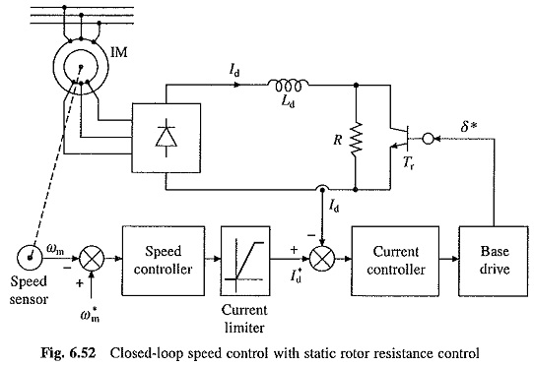

Compared to conventional rotor resistance control, static rotor resistance control has several advantages such as smooth and stepless control, fast response, less maintenance, compact size, simple closed-loop control and rotor resistance remains balanced between the three phases for all operating points.

**Slip Power Recovery Scheme:**

This system is mainly used for Induction motor speed control. The speed control in induction motor has poor efficiency due to wasting of slip power in the rotor circuit. By using recovery schemes the induction motor speed is controlled to avoid slip power loss.

The slip power recovery scheme is classified into two types:

1. Static Kramer drive,
2. Static Scherbius drive.

**Kramer System:**

* It consists of main induction motor M, the speed of which is to be controlled.
* The two additional equipments are, dc motor and rotary converter.
* The dc side of rotary converter feeds a dc shunt motor commutator , which is directly connected to the shaft of the main motor.
* A separate dc supply is required to excite the field winding of dc motor and exciting winding of a rotary converter.

* The variable resistance is introduced in the field circuit of a dc motor which acts as s field regulator.

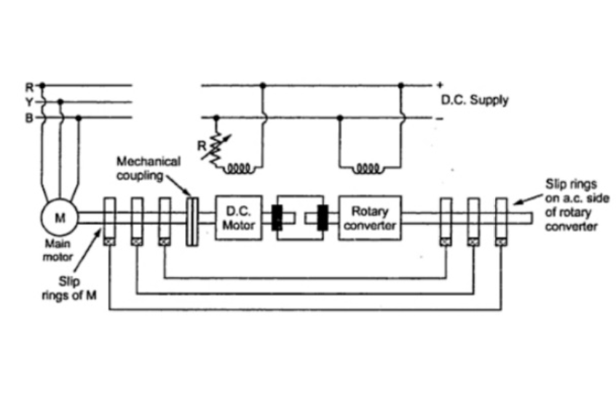

* The speed of the set is controlled by varying the field of the dc motor with the rheostat R. When the field resistance is changed, the back emf of motor changes.
* Thus the dc voltage at the commutator changes.
* This changes the dc voltage on the dc side of a rotary converter.
* Now rotary converter has a fixed ratio between its ac side and dc side voltages.
* Thus voltage on its ac side also changes. This ac voltage is given to the slip rings of the main motor.
* So the voltage injected in the rotor of main motor changes which produces the required speed control.
* Very large motors above 4000 kW such as steel rolling mills use such type of speed control.
* The main advantage of this method is that a smooth speed control is possible. Similarly wide range of speed control is possible.
* Another advantage of the system is that the design of a rotary converter is practically independent of the speed control required.
* Similarly if rotary converter is overexcited, it draws leading current and thus power factor improvement is also possible along with the necessary speed control.

**Scherbius System:**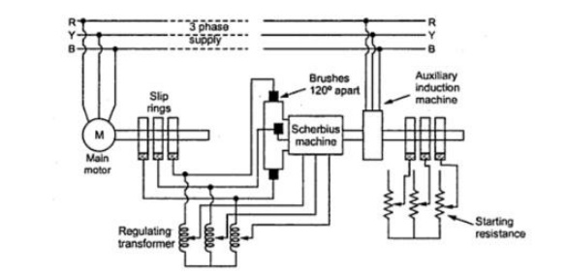

* This method requires an auxiliary 3 phase or 6 phase ac commutator machine which is called Scherbius machine.
* The difference between Kramer system and this system is that the Scherbius machine is not directly connected to the main motor, whose speed is to be controlled.

* The Scherbius machine is is excited at a slip frequency from the rotor of a main motor through a regulation transformer.

* The taps on the regulating transformer can be varied, this changes the voltage developed in the rotor Scherbius machine, which is injected into the rotor of main motor.
* This control the speed of the main motor, the scherbius machine is connected directly to the induction motor supplied from main line so that its speed deviates from a fixed value only to the extent of the slip of the auxiliary induction motor.

* For any given setting of regulating transformer, the speed of the main motor remains substantially constant irrespective of the load variations.

* Similar to the Kramer system, this method is also used to control speed of large induction motors.
* The only disadvantage is that these methods can be used only for slip ring induction motors.

Advantages of slip power recovery scheme:

The main advantage of this method is that a smooth **speed control** is possible.

Similarly wide range of **speed control** is possible.

Another advantage of the system is that the design of a rotary converter is practically independent of the **speed control** required.

***CLOSED LOOP CONTROL OF INDUCTION MOTOR THROUGH VSI***

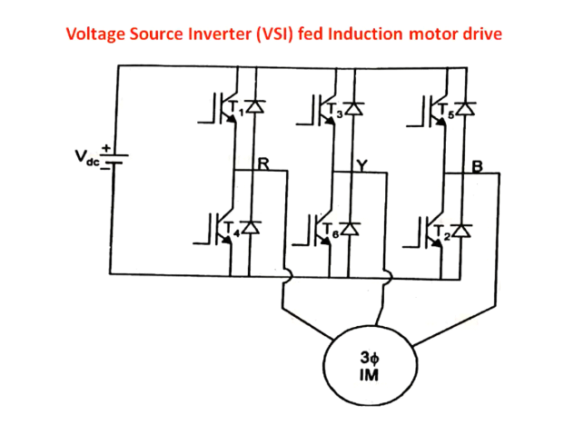

figure : 1

figure : 1 represents circuit diagram induction motor fed from a voltge source inverter.

***modes of VSI fed inverter:***

1. Stepped wave inverter mode

2. Pulse width modulation mode

Voltage source inverter can be operated in two mode either in PWM ( pulse width modulation ) mode or in stepped wave inverter mode, depends upon what pulse we are providing.

In stepped wave inverter mode only frequency can be controlled internally but it can't control magnitude of voltage internally. For controlling magnitude of voltage external controllers are requird.

PWM inverter has the function to control both frequency and voltage magnitude internally. So, here no external converters are required

***Stepped Wave Inverter Mode:***

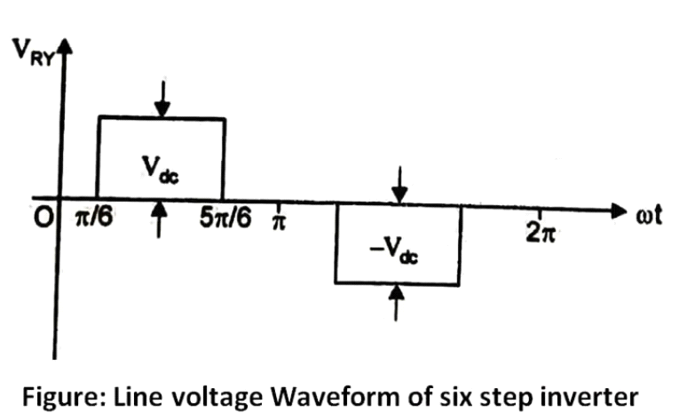

This wave form representating a stepped wave inverter wave form for RY line voltage . Firing angle is /6.

Here we are having total 6 thyrister. so each thyrister will conduct for 60 degree.

As you can see that this wave form is symmetric, so if you take average value then entire thing will be zero. so we are going to take average vulue for one half cycle and you can see for each half cycle the magnitude of voltage remains same . so we can conclude here that in stepped wave inverter the magnitude of voltage wave form remains same and can't be changed internally. Here we introduce some external components for coltrolling voltge externally.

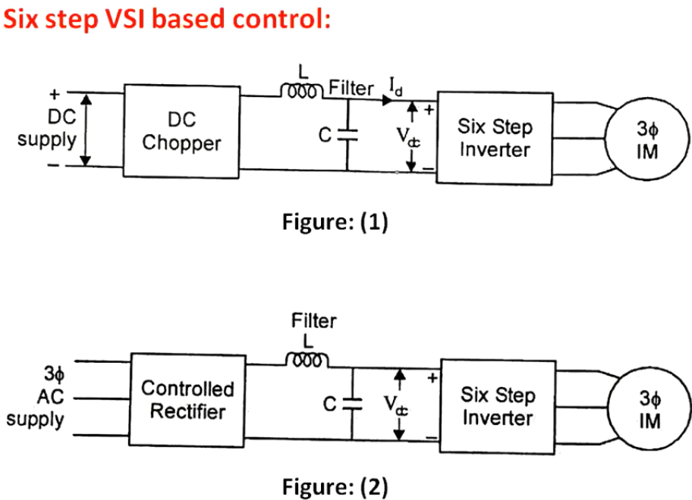

Figure(1): In DC supply to get controlled voltage in the output of six step inverter we provide controlled voltage to the input of the inverter. Here we are using chopper to get variable of controlled DC from fixed DC . So here external voltage coltrol is done in the chopper circuit.

here frequency can be controlled internally by changing timme period. Here propotionslly V and f must be varied to get controlled V/f ratio.

Figure(2): In three phase circuit we need controlled rectifier in the input of the six step inverter to get variable DC from three phase supply

***2. Pulse width modulation mode:***

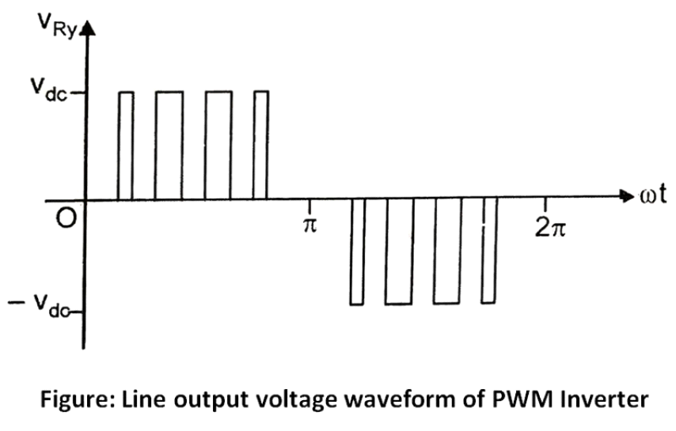

Here in no single pulse in PWM . So here entiren single pulse is devided into multiple pulses using pulse width modulated controlled based input to the gate of the inverter.

All the pulse width are not same. So here same agerave voltage is produced for one half cycle.For next cycle if you want to change the value of average voltage then you can change the width of the pulse based on the pulse width modulation. once the modulation index changes then based on this width changes and average value will also changed so that output voltage changes.

**CLOSED LOOP CONTROL OF CSI IM FED DRIVE**

**DEFINATION :-** The current source inverter converts the input direct current into an alternating current. In current source inverter, the input current remains constant but this input current is adjustable. The current source inverter is also called current fed inverter. The output voltage of the inverter is independent of the load. The magnitude and nature of the load current depends on the nature of load impedance.

## Current Source Inverter Control of Induction Motor

A thyristor Current Source Inverter Control of Induction Motor (CSI) is shown in Fig. 6.45. Diodes D1-D6 and capacitors C1-C6 provide commutation of thyristors T1-T6, which are fired with a phase difference of 60° in sequence of their numbers. It also shows the nature of output current waveform. Inverter behaves as a current source due to the presence of large inductance Ld in dc link.

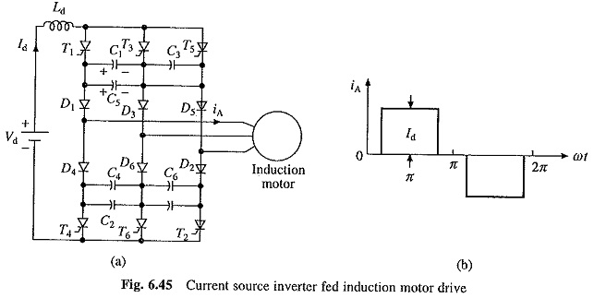

The fundamental component of motor phase current from Fig. 6.45(b) is

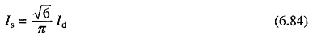

For a given speed, torque is controlled by varying dc link current Id by changing the value of Vd. Therefore, when supply is ac, a controlled rectifier is connected between the supply and inverter and when supply is dc, a chopper is interposed between the supply and inverter (Fig. 6.46). The maximum value of dc output voltage of fully-controlled rectifier and chopper are chosen so that the motor terminal voltage saturates at rated value.

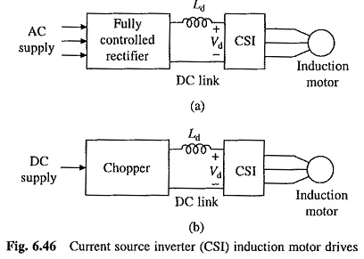

The major advantage of Current Source Inverter Control of Induction Motor is its reliability. In case of VSI (Fig. 6.37(a)), a commutation failure will cause two devices in the same leg (e.g. Tr1 and Tr4) to conduct. This connects conducting devices directly across the source. Consequently, current through devices suddenly rises to dangerous values. Expensive high speed semiconductor fuses are required to protect the devices. In case of Current Source Inverter Control of Induction Motor, conduction of two devices in the same leg does not lead to sudden rise of current through them due to the presence of a large inductance Ld. This allows time for commutation to take place and normal operation to get restored in subsequent cycles. Further, less expensive HRC fuses are good enough for protection of thyristors.

As seen in Fig. 6.45, motor current rise and fall are very fast. Such a fast rise and fall of current through the leakage inductance of the motor produces large voltage spikes. Therefore, a motor with low leakage inductance is used. Even then voltage spikes have large value. The commutation capacitors C1-C6 reduce the voltage spikes by reducing the rate of rise and fall of current. Large value of capacitors is required to sufficiently reduce the voltage spikes. Large commutation capacitors have the advantages that cheap converter grade thyristors can be used but then they reduce the frequency range of the inverter, and therefore, speed range of the drive. Further, due to large values of inductor Ld and capacitors, the Current Source Inverter Control of Induction Motor drive is expensive and has more weight and volume.

### Regenerative Braking and Multiquadrant Operation:

When inverter frequency is reduced to make synchronous speed less than motor speed, machine works as a generator. Power flows from machine to dc link and dc link voltage Vd (Fig. 6.46) reverses. If fully-controlled converter of Fig. 6.46(a) is made to work as an inverter, the power supplied to dc link will be transferred to ac supply and regenerative braking will take place, Thus, no additional equipment is required for regenerative braking of CSI drive of Fig. 6.46(a). Change of phase sequence of Current Source Inverter Control of Induction Motor will provide motoring and braking operations in the reverse direction.

The drive of Fig. 6.46(b) can have regenerative braking capability and four-quadrant operation if a two quadrant chopper providing current in one direction but voltage in either direction is used.

### Closed Loop Speed Control of CSI Drives:

A closed loop Current Source Inverter Control of Induction Motor drive is shown in Fig. 6.47. Actual speed ωm is compared with the reference speed ω*m. The speed error is processed through a PI controller and slip regulator. The slip regulator sets the slip speed command ω*s1. The synchronous speed obtained by adding ωm ω*s1, determines the inverter frequency. Constant flux operation is obtained when slip speed ωs1 (or rotor frequency) and Is have relationship of Fig. 6.44(b). Since Id is proportional to Is, according to Eqn. (6.84), a relation similar to Fig. 6.44(b) exists between ωs1 and Id for constant flux operation. Based on the value of ω*s1, the flux control block produces a referent current I*d, which through a closed-loop current control adjusts the dc link current Id to maintain a constant flux. The limit imposed on the output of the slip regulator, limits Id at the inverter rating. Therefore, any correction in speed error is carried out at the maximum permissible inverter current and maximum available torque, giving fast transient response and current protection.

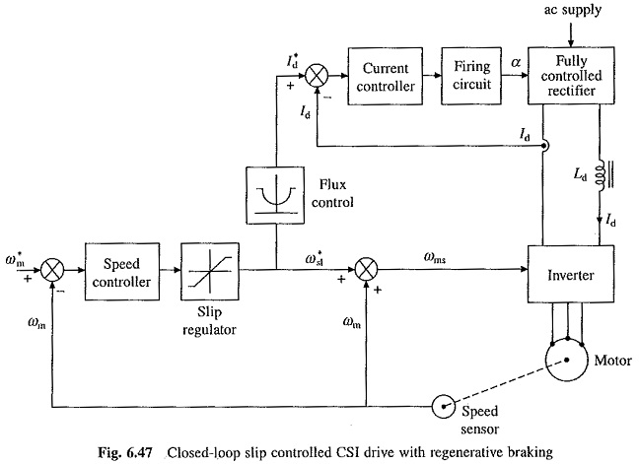

Beyond base speed, machine terminal voltage saturates as explained already. Flux control and closed-loop control of Id are made ineffective. To operate the drive up to rated inverter current, the slip speed limit of the [slip](http://www.allaboutcircuits.com/) regulator must increase linearly with frequency. This is realized by adding to the slip regulator output a signal proportional to frequency.

**ADVANTAGES OF CURRENT SOURCE INVERTER**

* CSI is used in many applications due to its flexibility & good property of commutation as their is no capacitor.
* CSI operates on closed loop & also capable of generation of variable frequency.
* The major merit of CSI is its reliability say in case of CSI , a commutation failure in the same leg does not occur due to the presence of a large inductance Ld.

**Characteristics:**

* For below rated speed, motor operates at constant flux mode.
* For above rated speed, motor operates at field weakening mode.
* For speed equal to rated speed, the voltage reach its rated value and no further increase of speed.

The characteristics are shown below on taking percentage slip on x-axis and percentage torque on y-axis.

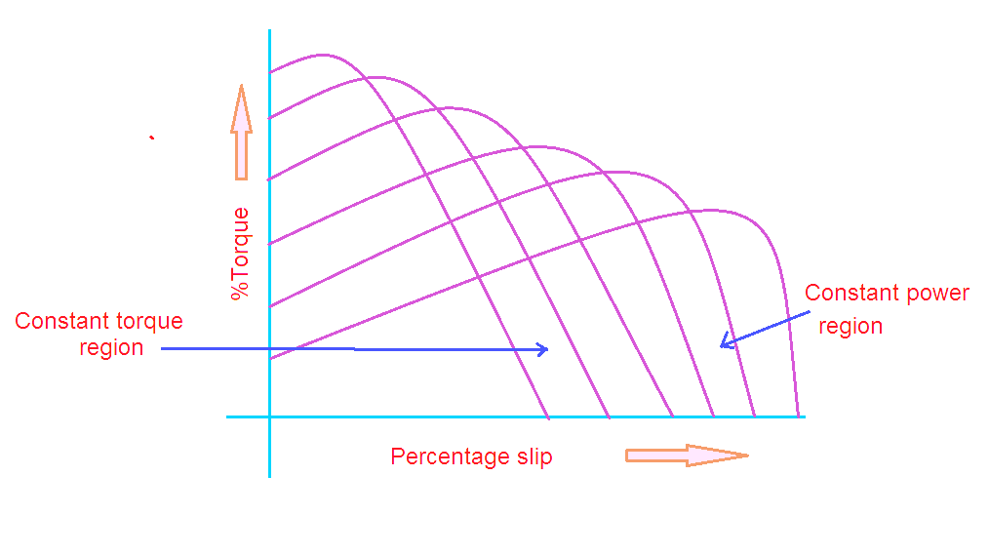

**Advantages:**

1. CSI is robust and simple

2. Four quadrant operation is possible

3. Controlling the speed in simple way

4. Better controlled performance.

Disadvantages:

1. Cost is expensive with PWM technique

2. Unsupported for multi-motor operation

3. CSI not used in open loop control drives

4. Undesirable dynamic performance

5. At no-load condition it is difficult to operate.

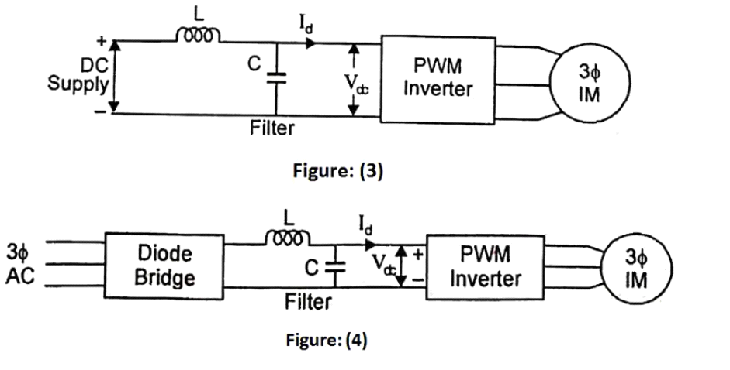

Figure(3) : Here in case of DC supply we don't need any external device to control DC voltage or to send controlled voltage to the PWM inverter as PWM inverter can control voltage internally.

Figure(4) : In case of three phase supply we just need to have a diode bridge to convert three phase supply to DC supply.

***Closed Loop Control Of VSI Fed Induction Motor:***

This control scheme is only to automate the open loop control of what we have seen previously.

automation means it is not necessary to change or control firing angle , duty cycle and time period of inverter every time for requird speed every time.

This closed loop will work based on reference speed and automatically system will work accordingly.

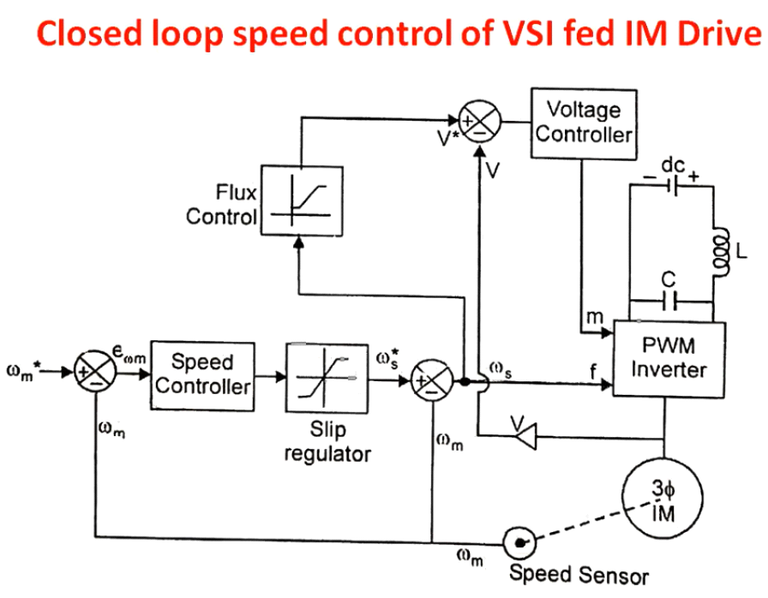

1. wm is actual speed of IM

2. Wm* is reference speed of IM

3. Ws* is slip frequency speed

4. V* is reference voltage

5. V is actual operating voltage

6. M is modulation index

7. F is frequency control input

There are two control input in PWM inverter:

* modulation index (m)
* frequency fontrol input (f)

Based on this controlling inputs PWM INVERTER can control voltage as well as frequency. Voltage variation will be done by varying modulation index and frequency variation will be done by adjusting frequency controlled input.

Initially induction motor is running at some speed ( actual speed ) and that speed is sensed by the speed sensor ( techo generator).But we need IM to run at reference speed. So we give reference speed at the input of the system. speed controller is a PI controller that generates a slip value propotional to speed error between Wm* (reference speed/input speed of IM) and wm is actual speed of IM generated by first comparator.

This slip value is passed through the slip regulator. The slip regulator will see whether the value of slip in actual range or not. (range of slip is -1 to 1 .0 to 1 is for motoring mode and -1 to 0 is for generating mode).If the value of slip is not in the range the slip regulator will not provide any output. If the value of slip is in the range only then the slip regulator will work And the slip regulator produce a angular speed propotional to the slip at it's output.And this angular speed is called slip frequency speed.

This slip frequency speed furthur compared with actual speed of IM and produce such a speed which is propotional to frequency control input, so from this speed we get frequency control input that is given to the PWM inverter to control frequency.

Again that slip frequency speed goes to flux control and flux control provide voltage output propotionally . This voltage is reference volatage. Then controller takes working voltage and reference voltage as input and gives output as modulation index.

For each cycle of the loop fequency control input and modulation index will be updated and accordingly speed of the IM will change and after few cycle speed of IM gets stable.

5.

MATLAB SIMULATION

**MATLAB SIMULATION OF SINGLE PHASE FULL BRIDGE INVERTER**

**MEASURING INSTRUMENT REQUIRED :**

*Continuous powergui ,DC Voltage , Voltage measurement, Current measurement,* ***IGBT****/Diode, Series RLC branch, Pulse generator, Logical operator (NOT gate), Scope.*

*Let us take Supply DC voltage =* ***200 volts*** *& Frequency =* ***50 Hz***

*Parameter values of PULSE GENERATOR :*

* *Amplitude =* ***1***
* *Period =* ***0.02 sec***
* *Pulse width =* ***50%***
* *Phase delay =* ***0***

*LOAD parameter values (RL) :*

* *Resistance =* ***1 Ohms***
* *Inductance =* ***0.01 Henry***

**CIRCUIT DESIGN :**

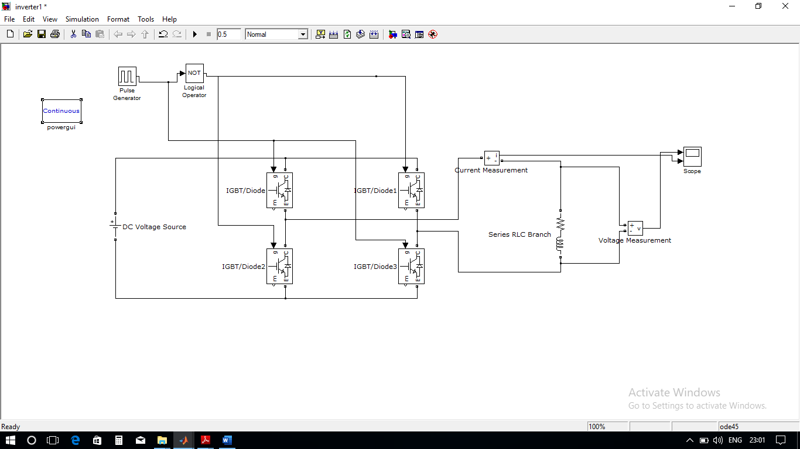

**SIMULATION CHARACTERSTICS GRAPH OF CURRENT & VOLTAGE ACROSS RL LOAD :**

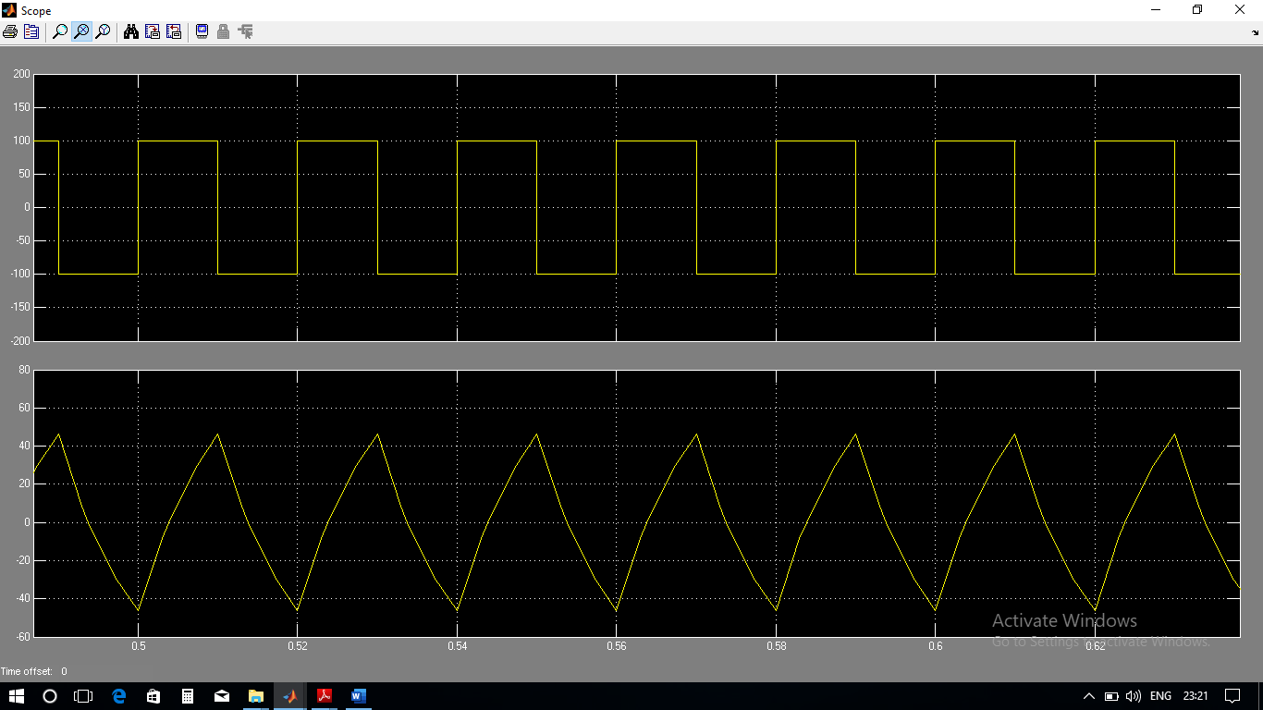

MATLAB SIMULATION OF 180 DEGREE CONDUCTION MODE OF THREE PHASE INVERTER

**MEASURING INSTRUMENT REQUIRED:**

Continuous powergui, DC voltage source, Voltage measurement, Ground point, MOSFET, Pulse generator, 3 phase series RLC load, Scope.

Let us say, Supply voltage = **24 volts.**

MATLAB important steps to enter input in pulse generator:

Frequency = 50 Hz; therefore time period, T = 1/f= **0.02 sec**.

* *360 degree =* ***0.02 sec***
* *180 degree =* ***0.01 sec***
* *Pulse width = (120/360)*100 =* ***33.33 %***

Therefore, 1 degree corresponds to **5.55e-5 sec.**

1)For firing angle of 0 degree, we have set T1= **0 sec.**

2)For firing angle of 120 degree, we have set T3= 120*5.55e-5= **6.66e-3 sec.**

3)For firing angle of 240 degree, we have set T5= 240*5.55e-5= **0.01332 sec**.

4)For firing angle of 120 degree, we have set T4= 120*5.55e-5= **9.99e-3 sec.**

5)For firing angle of 120 degree, we have set T6= 120*5.55e-5= **0.01655 sec**.

6)For firing angle of 420-360= 60 degree, we have set T2= 60*5.55e-5= **3.33e-3 sec**.

**Circuit design**

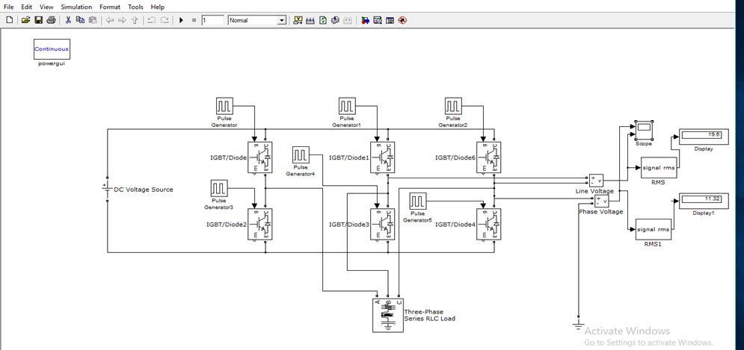

Simulation characteristics graph

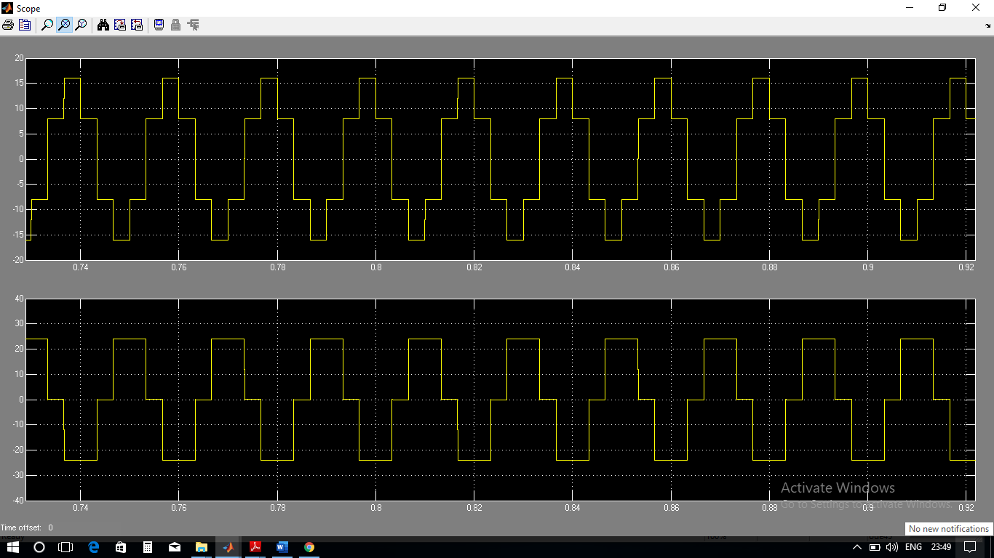

MATLAB SIMULATION OF 120 DEGREE CONDUCTION MODE OF THREE PHASE INVERTER

MEASURING INSTRUMENT REQUIRED :

*Continuous powergui, DC voltage source, Voltage measurement, Ground point, MOSFET, Pulse generator, 3 phase series RLC load, Scope.*

*Let us say, Supply DC voltage =* ***24 volts.***

MATLAB important steps to enter input in pulse generator :

Frequency = 50 Hz ; therefore time period , T = 1/f= **0.02 sec.**

* ➢***360 degree = 0.02 sec***
* ***➢180 degree = 0.01 sec***
* ***Pulse width = (120/360)*100 = 33.33 %***

Therefore, 1 degree corresponds **to 5.55e-5 sec.**

1)For firing angle of 0 degree, we have set T1= **0 sec.**

2)For firing angle of 120 degree, we have set T3= 120*5.55e-5= **6.66e-3 sec.**

3)For firing angle of 240 degree, we have set T5= 240*5.55e-5= **0.01332 sec.**

4)For firing angle of 120 degree, we have set T4= 120*5.55e-5= **9.99e-3 sec.**

5)For firing angle of 120 degree, we have set T6= 120*5.55e-5**= 0.01655 sec.**

6)For firing angle of 420-360= 60 degree, we have set T2= 60*5.55e-5= **3.33e-3 sec.**

**CIRCUIT DESIGN:**

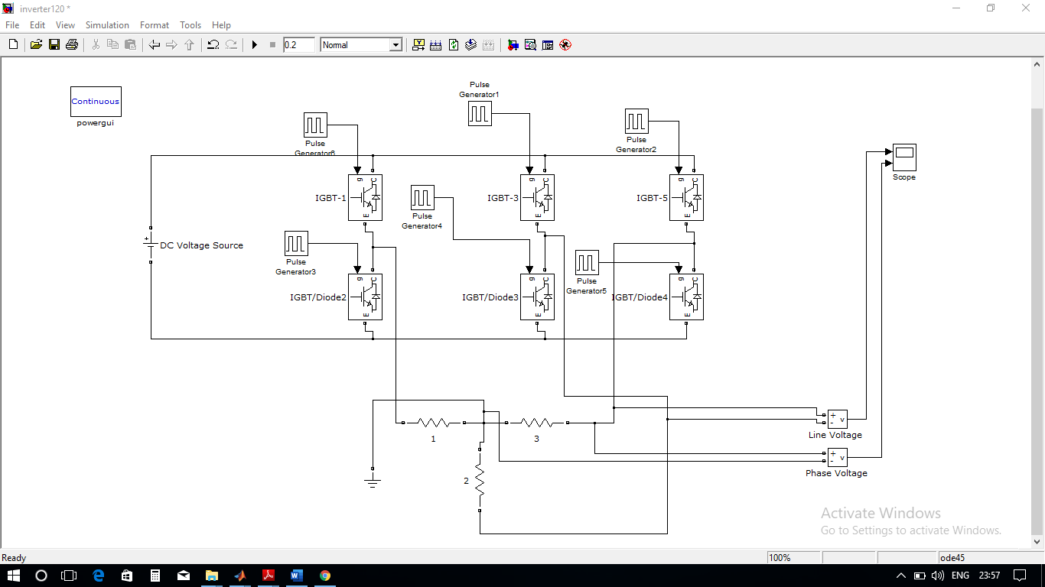

**SIMULATION CHARACTERISTICS GRAPH :**

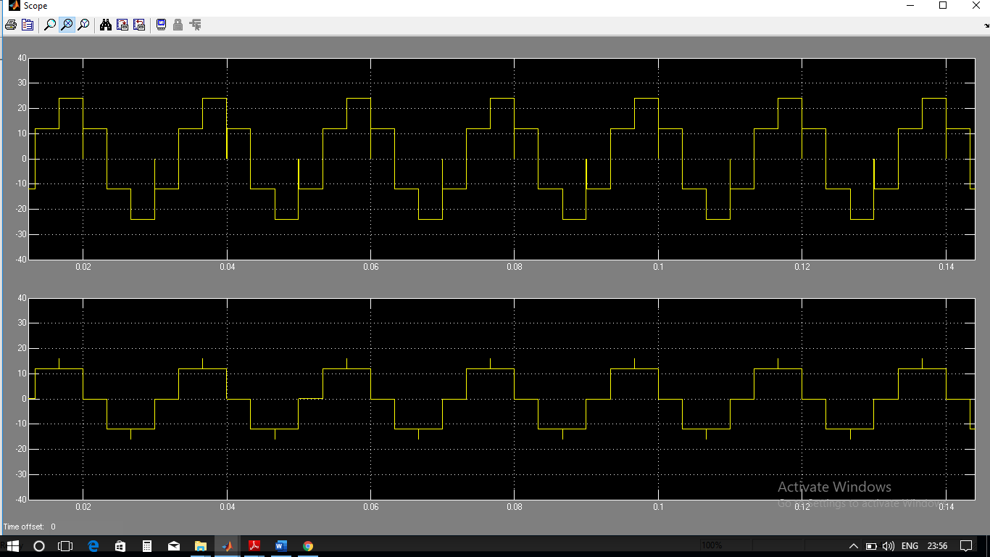

MATLAB SIMULATION OF 3 PHASE SINE PULSE WIDTH MODULATION (PWM) INVERTER WITH RL LOAD:

**MEASURING INSTRUMENT REQUIRED :**

***Discrete*** *powergui, Modulating* ***Sine wave*** *,Repeating sequence such as* ***Saw tooth generator block*** *,Constant , Product , Divide, Relational Operator* ***( >= )*** *, Logical NOT gate , DC voltage supply ,* ***IGBT****/ diode ,Current measurement , Asynchronous Machine SI units* ***(Squirrel Cage)*** *, MUX , DEMUX , Terminator block , Scope.*

*Let us take Supply DC voltage =* ***48 volts*** *& Angular frequency =* ***2*pi*50******rad/sec****.*

*PARAMETERS VALUE OF* ***MODULATING SINE WAVE :***

* *Ranges of Phase (rad) :* ***-2*pi/3*** *,* ***0*** *,* ***2*pi/3*** *.*

***CIRCUIT DESIGN :***

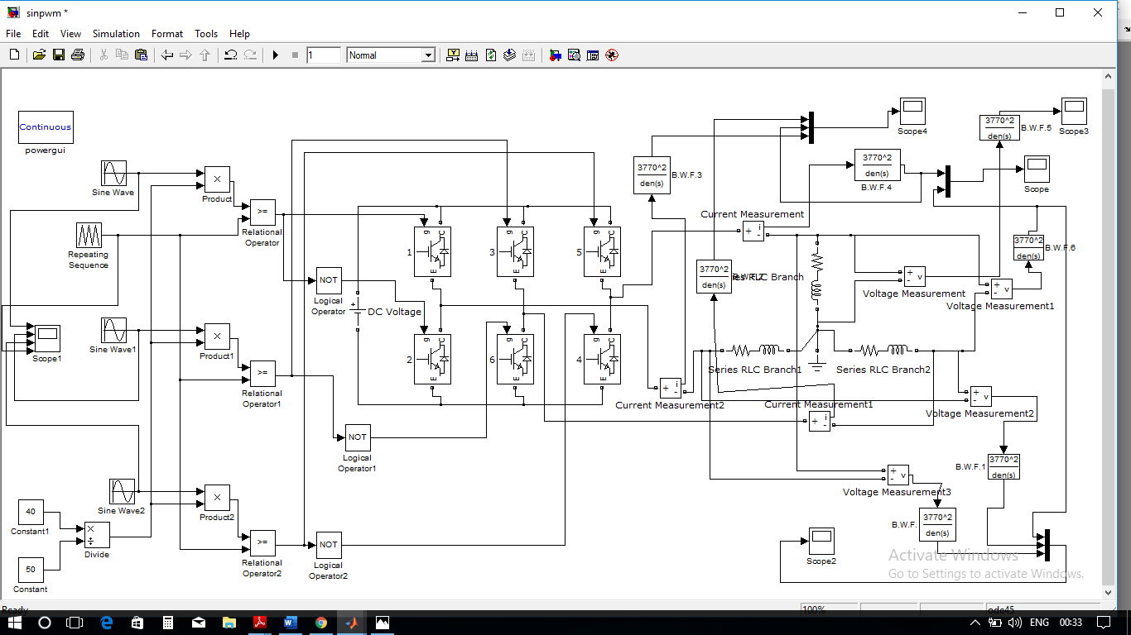

*SIMULATION GRAPH OF SINE PWM :*

***INPUT SIGNAL:***

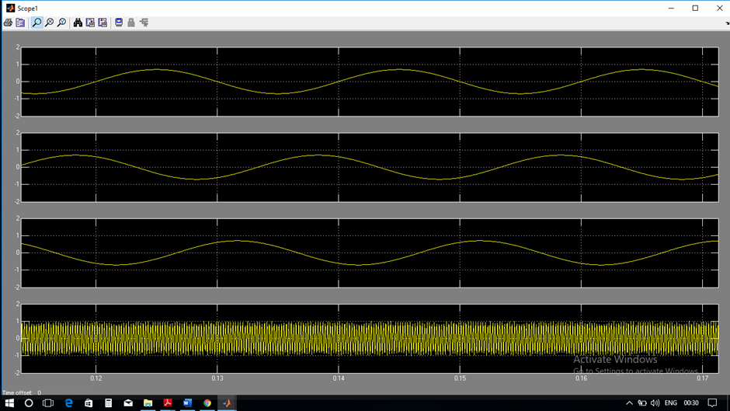

*LINE VOLTAGE AND CURRENT WAVEFORMS:*

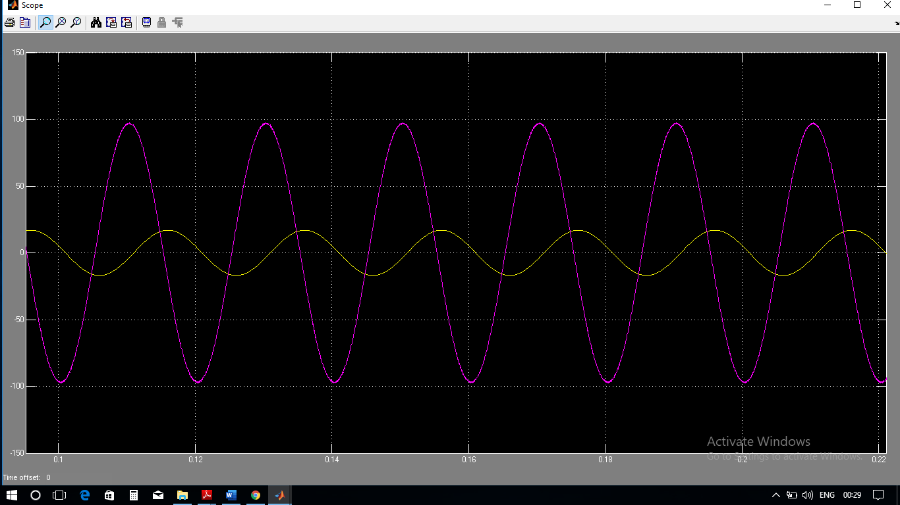

*THREE PHASE VOLTAGE WAVEFORMS:*

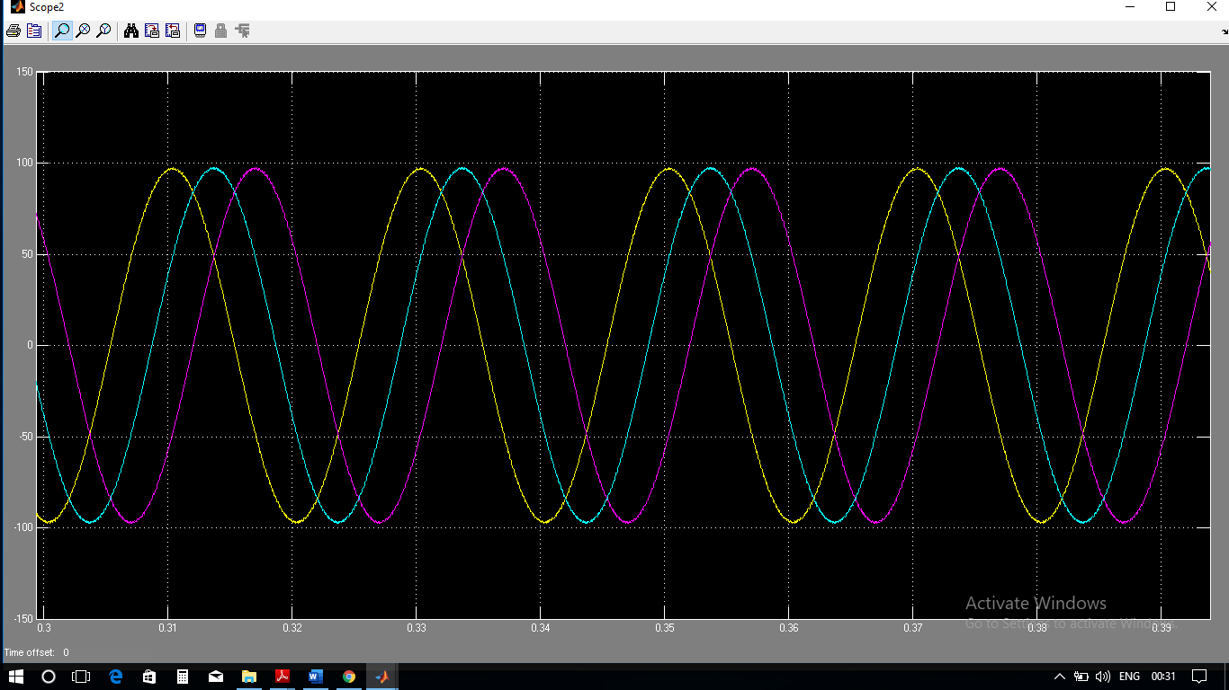

*THREE CURRENT WAVEFORMS:*

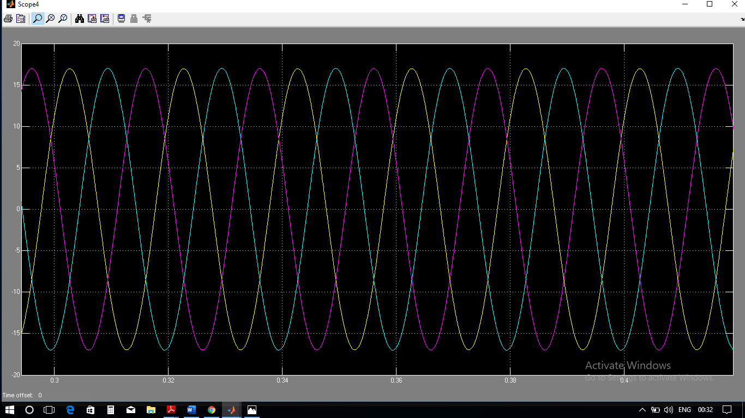

MATLAB SIMULATION OF 3 PHASE SINE PULSE WIDTH MODULATION (PWM) INVERTER WITH ASYNCHRONOUS MOTOR LOAD:

**MEASURING INSTRUMENT REQUIRED :**

***Discrete*** *powergui, Modulating* ***Sine wave*** *,Repeating sequence such as* ***Saw tooth generator block*** *,Constant , Product , Divide, Relational Operator* ***( >= )*** *, Logical NOT gate , DC voltage supply ,* ***IGBT****/ diode ,Current measurement , Asynchronous Machine SI units* ***(Squirrel Cage)*** *, MUX , DEMUX , Terminator block , Scope.*

*Let us take Supply DC voltage =* ***48 volts*** *& Angular frequency =* ***2*pi*50******rad/sec****.*

*PARAMETERS VALUE OF* ***MODULATING SINE WAVE :***

* *Ranges of Phase (rad) :* ***-2*pi/3*** *,* ***0*** *,* ***2*pi/3*** *.*

*PARAMETERS OF ASYNCHRONOUS MACHINE (SI) :*

* *Rotor type :* ***Squirrel cage***
* *Mechanical input* ***: Torque Tm***
* *Reference frame :*

1. *Rotor*
2. *Stationary*
3. *Synchronous*

***CIRCUIT DESIGN :***

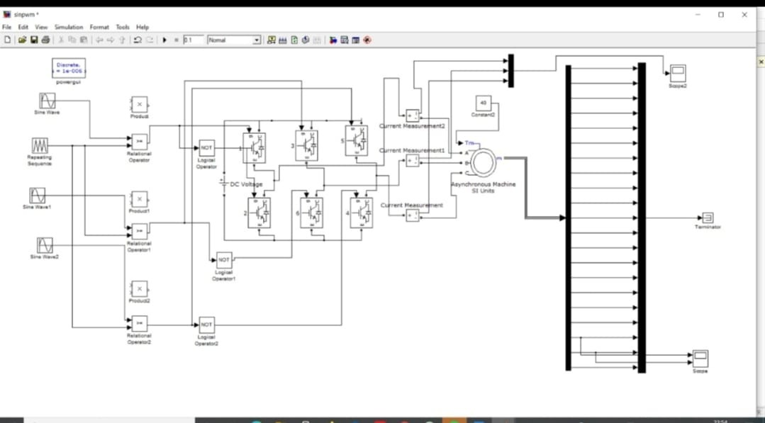

*SIMULATION GRAPH OF SINE PWM :*

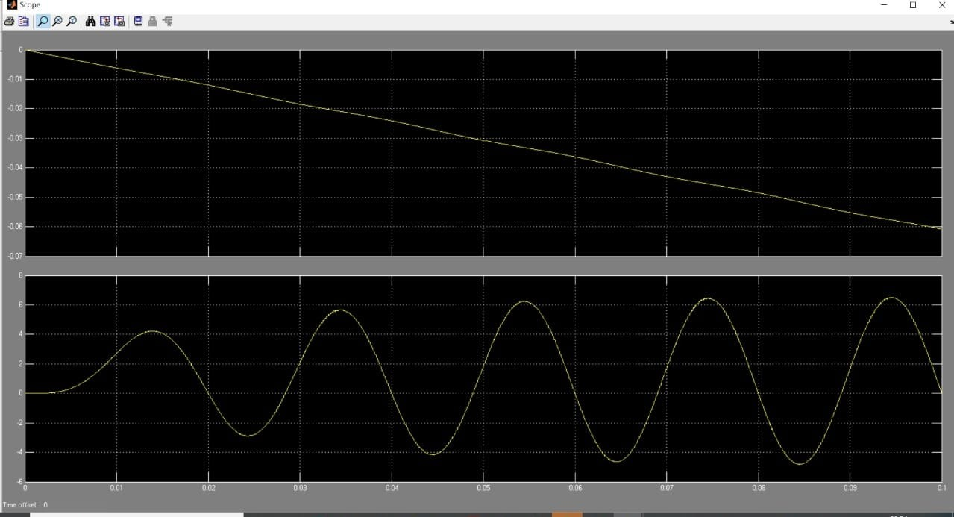

REFERENCES

* ELECTRICAL MACHINES BY ASHFAQ HUSSAIN .
* ELECTRICAL MACHINERY BY PS BHIMBHRA.
* POWER ELECTRONICS BY PS BHIMBHRA.
* CONTROL SYSTEM ENGINEERING BY RAMESH BABU AND ANANDANATARAJAN R.
* FUNDAMENTALS OF ELECTRIC DRIVES BY G.K DUBEY.
* THROUGH INTERNET , VARIOUS WEBSITES.